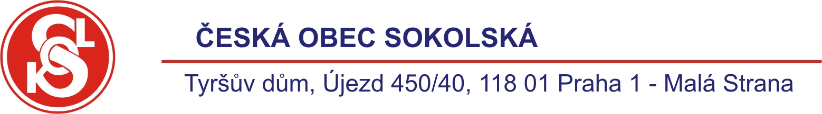
International seminar

Exercises of Parents and Children (PaCh)
(2nd announcement - Invitation )

Organizer: Czech Sokol Organization

Venue: Czech Republic, Prague

Term: 9 – 11 April, 2010

Target group: - instructors of the respective category,
- leaders of the sports organizations intending to introduce or enhance
these exercises in their organizations

Scheduled programme:
Friday, 9 April, 2010:
Arrivals, accommodation, Tyrš House sightseeing, history and the present of Sokol

Saturday, 10 April, 2010:
Appratus as the motivation
Theoretical part: - Game and the pre-school child
- Development of rough and fine motor activities

Practical part: - Exercises with balls
- Apparatus handling
- Exercises with gymballs

Evening: - Sightseeing of the historical part of Prague

Sunday, 11 April, 2010:
Let´s practice without apparatus
Theoretical part: - How to attract the attention of children
- The word of the psychologist

Practical part: - Unconventional motivation
- Verbal motivation for parents and children

Exchange of ideas – opportunity for the participants to present their
good practices

Departures of the participants

Printed materials on the presented themes will available
Languages: Czech, English

Financial conditions: international and local transport, accommodation (in Sokol hostel (10 Eur/night) or Sokol hotel – 72 EUR single, 79 EUR double room/night) and meals at the expenses of sending organization (participants of the seminar).

Participation fee: 40 EUR

Questions and the below applications to be sent- by email, fax or post - by 10 March at the latest, to:

Vladimir Dostal
Head of International Affairs
Czech Sokol Organiza
Újezd 450
118 01 Praha 1 – Malá Strana

vdostal@sokol.eu
tel.: +420 257 007 244
mob.: +420 737 225 863
fax: +420 257 320 580

Application

For the International Seminar Exercises of Parents and Children organized by the Czech Sokol Organization in Prague, 9 – 11 April, 2010

First name: Surname:

Position:

Contact address:

Email:

Tel.:

Sending organization:

My own presentation: yes no

Theme:

Signature:

