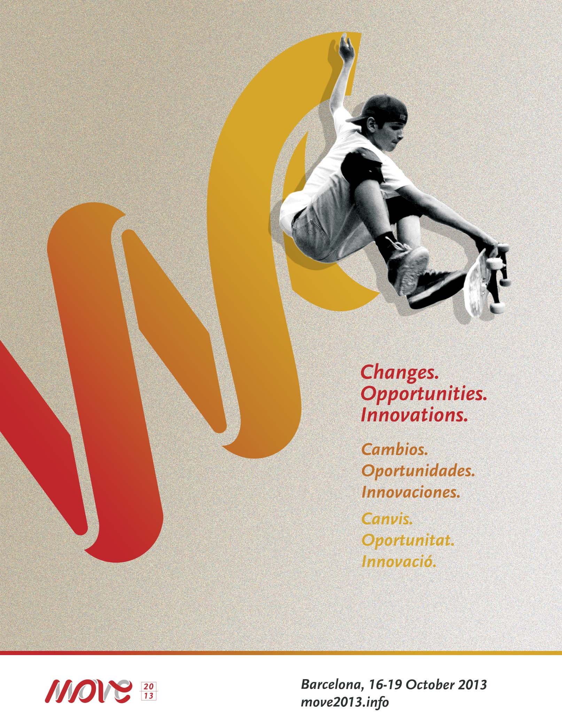**MOVE CONGRESS 2013**

**BOOK OF ABSTRACTS**

**Thursday 17.10.2013: Opening of the day - Leadership and innovation in a global market**

**Wouter Vermeulen, Corporate Responsibility Director Coca-Cola Europe**

**Active healthy lifestyle’ promotion and community investment**

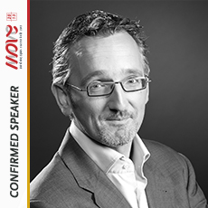As Corporate Responsibility Director, Health and Well-being, Wouter Vermeulen (°1967) is responsible for the development and co-ordination of The Coca-Cola Company’s strategy to promote healthy, balanced lifestyles across Europe. This includes engaging a wide array of stakeholders at European level: Commission, NGO’s, industry partners. Wouter represents Coca-Cola Europe at various industry platforms such as FoodDrinkEurope and the World Federation of Advertisers.

Wouter has 20 years of experience in corporate public affairs and communications. He held various positions such as spokesperson for the Belgian State Secretary for Development Cooperation, the Federation of Enterprises in Belgium and was managing partner at the leading Belgian online agency. He joined Coca-Cola in 2006. In these various positions, he has always been involved in developing the sustainability strategy for the different organizations he has worked for.

**Thursday 17.10.2013: Opening of the day - Leadership and innovation in a global market**

**Robbert De Kock, World Federation of the Sporting Goods Industries (WFSGI), Switzerland**

**Physical activity and sport promotion: it’s our business!**

**Models and challenges for the sporting goods industry in a global market**

The World Federation of the Sporting Goods Industry (WFSGI) is the world authoritative body for the sporting goods industry and the industry relation towards the International Sports Federations, UN agencies and governments. In this role, among others, WFSGI advocates for sport and physical activity with WHO, UNESCO, ECOSOC.

Our vision is a globally healthy society in which people can be physically active and do sport without barriers or constraints.

Every day our industry is reaching millions of people all over the world – promoting directly and indirectly physical activity, sport and active transportation.

Our members spend a significant amount of their budgets on the promotion of sport and physical activity from innovative products to state of the art communication. The sporting goods industry initiates and/or supports grass-root activities, school projects, community programs, social media events and apps to support and/or motivate people to exercise and many more.

We are striving to get people active and to bring back the fun to sport and physical activity. Sport has a positive image which fuels our endeavors. The power of sport brands lies in emotions and a positive image, but also our sports and cultural heroes act as role models for the young generations.

The presentation will give an overview of our role, tasks and activities to take a sustainable leadership in the promotion of physical activity and to make a contribution to public health on a global level.

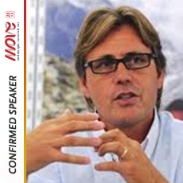**Robbert de Kock** is WFSGI Secretary General since September 2007 and has more than 25 years of industry experience from wholesale to retail with high knowledge on the manufacturer processes.

He started his sporting goods career in the sports retail during his studies where after he moved to Lausanne/Switzerland to become a professional badminton player and coach. It was in 1991 that the IOC opened an opportunity to be an active sportsman and to work at the IOC Multi Media Department. Before becoming the WFSGI Secretary General, he worked 12 years for the Berne based IIC-INTERSPORT International Corporation in various functions. In the last six years, as Director License & Global Business Development, he was responsible for the full process in the expansion of the INTERSPORT group in Europe, Middle East and Asia. Robbert de Kock has an education in economics and marketing in Rotterdam with various complementary studies.

**Thursday 17.10.2013: Opening of the Day - Leadership and innovation in a global market**

**Prof. Silvano Zanusso, Technogym, Italy**

**Technogym in a global market**

How can a company innovate, grow and maintain a leadership position?

It can happens only through a clear Vision; that of Technogym require a staunch commitment to promoting **Wellness**, a better lifestyle through regular physical activity, healthy diet and a positive mental approach that have been the ethos of Technogym for over 2 decades. **All-around innovation** and a Total Wellness Solution set Technogym, the Wellness Company, apart, as does the company’s founding philosophy of fusing business with social responsibility.

President and founder, Nerio Alessandri, developed his first fitness equipment in his garage in 1983 at the age of 22. As Italy's youngest ‘Cavaliere del Lavoro’ (Italian industry knighthood), he and Technogym have been continuously recognized for excellence. In 2003 Ernst & Young awarded Alessandri the Italian Entrepreneur of the Year. For three consecutive years, the company has been merited as a Great Place to Work, winning 1st place in 2003 for the best working conditions in Italy and Europe.

**Research and innovation** have always represented the key values behind the development of products and services. Alongside with quality and reliability, **design** represents a Technogym distinctive mark granting to the company several international awards such as the **Red Dot Design Award**, one of the most prestigious international award for high design quality, expressing innovation in form and function in a exemplary manner.

The new frontier is now that of supporting the fitness and wellness market in the development of a **Wellness Ecosystem**, where devices, cloud based platforms and services are joint together to help the consumer and the community in achieving a wellness lifestyle.

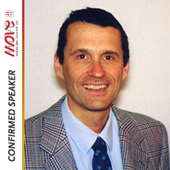**Dr Silvano Zanuso** received his Bachelor Degree in Exercise Science at the ‘University of Padua’, his Master of Science at the ‘Manchester Metropolitan University’ and his Ph.D. in Clinical Exercise Physiology at the ‘Universidad Europea de Madrid’.

He is the director of the Technogym Medical & Scientific Department.

He is Visiting professor at the Faculty of Science at the University of Greenwhich in London. His main scientific interest is on the effects of physical activity and exercise on subjects with metabolic disorders.

Silvano was consultant for health promotion for different governments and public institutions; he held conferences and educational programs in more than twenty countries and he currently publishes in scientific indexed journals.

**Thursday 17.10.2013: Parallel Session 1 – Cross sector policies and Physical activity promotion**

**Bernhard Ensink, European Cyclists’ Federation ECF, Belgium**

**Space for our future - How physical activity fits into society's global challenges for well-being, health and human rights.**

In this presentation Bernhard Ensink will show that cycling is an indicator for the liveable city of the future, when people can cycle they can also walk, play and interact in environments that are built for public well-being, physical activity and economic success. As the European and global leader on the development of cycling as active transport and tourism ECF is bringing together its own networks of advocates, cities and academics and connecting to the international (UN and EU) agencies, health organisations, environmental bodies, governments and city leaders who recognise those challenges and are trying to build liveable cities of the future.

One hundred years ago 20% of people lived in an urban area and it was still under 40% in 1990. But as of 2010, more than half of all people live in an urban area. By 2030, 6 out of every 10 people will live in a city, and by 2050, this proportion will increase to 7 out of 10 people. This has huge impacts on the way we move, the way we interact, the type of public services we need and all of these impact on our public health. And it has a particular impact on children and young people with restrictions on their play, mobility and potential for a healthy, physically active and economically active life. As these changes take place we need even wider alliances with the sport, physical activity and health sectors to ensure that the spaces of the future are open to all.

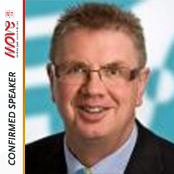**Dr Bernhard Ensink** has been Secretary General of the European Cyclists’ Federation (ECF) and Velo-city Series Director since 2006. Previously he was the Director of ‘Fietsersbond’, the Dutch Cyclists’ Union from 1998 until 2006. He has been Vice Mayor of the Dutch city of Coevorden (1994-1998), responsible for public affairs, spatial planning, environment, housing and finance. Born in 1956 in Germany, he has a doctorate in theology/ethics (Netherlands, 1995).

**Thursday 17.10.2013: Parallel Session 1 – Cross sector policies and Physical activity promotion**

**Dr. Jayne Greenberg, President’s Council on Fitness, Sports & Nutrition, USA**

**What kind of global challenges we face to ensure sustainable physical activity and public well-being? Experience from USA!**

The President’s Council on Fitness, Sports and Nutrition, along with other influential partners has been instrumental in advancing programs and policies to address physical activity and healthy lifestyles for all Americans as well as impacting the negative consequences of physical inactivy, one of the causes of childhood obesity. Through this presentation, the participants will learn about First Lady Michelle Obama’s initiative, Let’s Move along with the most recent program, Let’s Move in Schools; the Presidential Youth Fitness Program, an outcome of the White House Task Force on Childhood Obesity, to bring one national youth fitness assessment and educational program to schools; Designed to Move proffered by Nike and 33 Global Partners, with a shared vision of One Mission and Two Asks; and the newly launched I Can Do It, You Can Do It, a physical activity program to impact persons with disabilities. All programs are designed to impact youth and adults where they Live, Work, Learn, and Play. This presentation will include a variety of multimedia to showcase the programs in this presentation.

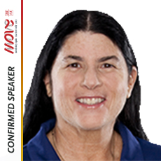**Dr. Jayne Greenberg** is the District Director of Physical Education and Health Literacy for Miami-Dade County Public Schools. Throughout her professional educational career, she has served as Special Advisor on Youth Fitness to the President’s Council on Physical Fitness and Sports; President of FAHPERD; chaired the Sport Development Committee for the United States Olympic Committee, USA Field Hockey; coordinated the Olympic Torch Relay Miami Leg for the Olympic Winter Games in Salt Lake City, and assisted the United States Department of Health and Human Services in the development of the I Can Do It, You Can Do It Program, a national initiative to address the physical activity levels of youth with disabilities. Dr. Greenberg was named as the 2005 National Physical Education Administrator of the Year by the National Association of Sport and Physical Education, received the 2005 Highest Recognition Award by the United States Secretary of Health, Michael Leavitt, received the March 2009 Point of Light Award by Florida Governor Charlie Crist and was appointed the Governor’s Council on Physical Fitness in 2009. In 2011 Dr. Greenberg was appointed by President Obama to serve on the President’s Council for Fitness, Sports, and Nutrition and in 2012 Dr. Greenberg was selected to serve on an Institute of Medicine Committee.

Dr. Greenberg has served as an international consultant, coordinating Olympic Education Programs in Canada; developed the Sport Science Curriculum at the University of Malaya, Kuala Lumpar, Malaysia; developed math and science sailing curriculum for the National Maritime Museum and Royal Observatory in London and Sydney Australia; developed a Conservation Safari in South Africa; developed the drug education curriculum for Antigua; presented at the International Olympic Committee Meeting in Singapore; and most recently assisted with the implementation of the sailing education program in Qingdao, China. In addition Dr. Greenberg has published a book, “Developing School Site Wellness Centers”, published numerous articles, co-authored a professional text, and has been a speaker at several state, national, and International conventions and meetings. In the past nine years

**Thursday 17.10: Parallel Session 1 - Cross sector policies and Physical activity promotion**

**Kelly Murumets, PatricipAction, Canada**

**Cross sector policies and Physical activity promotion: how to build partnerships in Canada?**

ParticipACTION is the national voice of physical activity and sport participation in Canada. Through social marketing and collaborative partnerships, we inspire and support Canadians to lead active, healthy lives.

Building strong partnerships is key to ParticipACTION’s success in reaching Canadians and building capacity for our not-for-profit partners to tackle Canada’s physical inactivity crisis.

One way that ParticipACTION has been striving to increase physical activity levels using a partnership approach is through the development of Active Canada 20/20 - A Physical Activity Strategy and Change Agenda for Canada. Active Canada 20/20 is the response of a broad cross-section of the physical activity community from across Canada who are committed to addressing the urgent national need to increase physical activity and reduce sedentary living. ParticipACTION’S aim in developing Active Canada 20/20 is to engage decision makers and rally the collaborative, coordinated and consistent efforts of all stakeholders at every level to make a difference for the well-being and sustainability of our social programs, our communities, our country, and, most importantly, our people.

ParticipACTION has provided the leadership in the development of Active Canada 20/20 by bringing together the most influential organizations in physical activity, recreation and sport to develop the Strategy, participate in its extensive consultation process and work together to develop an Implementation Framework, Communications Plan and Evaluation. This session will describe Active Canada 20/20’s inception to the approach being taken for its implementation engaging partners in every sector at all levels.

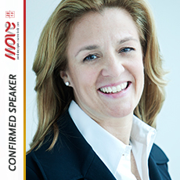**Kelly D. Murumets** is the President and CEO of ParticipACTION, the national voice of physical activity and sport participation in Canada. ParticipACTION has been an iconic Canadian brand since 1971 and was relaunched under Kelly’s dynamic leadership in 2007.

Kelly has been involved with the not-for-profit sector throughout her career. She is a member of the Bishop’s University Board of Governors, the Dean’s Advisory Council for the Laurier School of Business & Economics and is a Director of ParticipACTION. She has worked and volunteered for the Children’s Aid Society and Covenant House and speaks regularly to organizations across the country.

She holds an MBA from the Richard Ivey School of Business at the University of Western Ontario, a Master of Social Work from Wilfrid Laurier University (WLU) and a BA from Bishop’s University. Kelly won the Governor General’s Academic Medal and the Gold Medal at WLU, and is a member of the Golden Key International Honour Society.

Kelly was named to the 2007, 2009, 2011 and 2012 Canadian Association for the Advancement of Women and Sport and Physical Activity (CAAWS) Most Influential Women in Sport and Physical Activity list, named an Amazing Advocate on More Magazine’s Top 40 over 40 list and one of Canada’s Most Powerful Women: Top 100 in 2009. She has also been identified as one of the ‘Ten Most Influential Figures in Sport in 2012’ by the CBC. In 2013, Kelly was the recipient of the Queen Elizabeth II Diamond Jubilee Medal.

Kelly brings her passion for sport and physical activity to her personal pursuits. She enjoys skiing and scuba diving and has summited Mount Kilimanjaro and Mount Rainier.

**Thursday 17.10.2013: Parallel Session 1 – Cross sector policies and Physical activity promotion**

**Maria Luiza Souza Dias , SESC Sao Paulo, Brazil**

**How to build partnership to explore ways of encouraging and facilitating physical activity? Example from Brazil**

Promoting the physical activity and stimulating people to abandon a sedentary lifestyle has been one of the main challenges of SESC in the latest years.

In this sense, partnerships among public, private and non-governmental organizations, aiming to the improvement of social indicators, are always welcome. SESC as a national private institution, maintained by the commerce and service entrepreneurs, develops initiatives in culture, sport, health and leisure with a mission of promoting the wellbeing and a better quality of life of its priority public, as well as of citizens. In 2012, through the network of partners, more than 4 million people were attended by SESC São Paulo in its Sport for All programs.

Establishing partnerships requires continuous efforts and dialogs. In this perspective, SESC seeks to identify partners with specific characteristics to support projects; to establish common goals; to define and structure the work scope; to facilitate the engagement and cooperation by partners and stakeholders, and finally, to stimulate each partner to undertake the agreed goals, investing resources according to its structure and range.

A common goal allowed the establishment of partnerships among SESC, governments and non-governmental organizations to create the Move Brasil Campaign (inspired by the Now We MOVE Campaign of ISCA), with focus on physical activity and sports promotion, which, apart from spreading the message through an advertising campaign, had as highlight the MOVE BRASIL Week, that mobilized over 300.000 people in 116 cities across Brazil for nine days in 500 activities.

Campaigns such as Move Brasil and Challenge Day are examples of motivation process of co-creation and cooperation to develop projects in partnerships, whose result is making citizens aware of the benefits of enjoying a more active lifestyle.

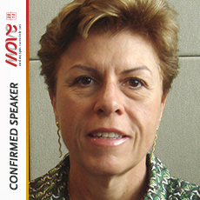**Maria Luiza Souza Dias** is Manager of Physical and Sportive Development of SESC São Paulo ((Social Service of Commerce – SESC). She is leading the MOVE Brazil Campaign. The aim of this campaign is to increase the number of Brazilians practitoners of sports and physical activities in their leisure until 2016, focusing in the well-being. She is also a coordinator of Challenge Day for the American Continent , that is a world campaign to incentive the regular practice of physical activities in benefit of health and well-being. Event that has been promoted around the world by TAFISA and coordinated by SESC SP in the American Continent. Maria Luiza was also chairwoman of the ISCA Latin American Committee: 2008 – 2010 and is Vice-President of ISCA - International Sport and Culture Association: 2011 - 2013.

**Thursday 17.10.2013: Parallel Session 2 - Engaging socially disadvantaged groups in sport and physical activity**

**Kerry McDonald, StreetGames, United Kingdom**

**StreetGames: An innovative approach to delivering sport and physical activity to UK disadvantaged young people**

StreetGames is the leading UK organization for promoting sport and physical activity for disadvantaged young people. There are over 4 million children and young people living in poverty in the UK. Affluent young people in the UK participate in sport twice as much as their poorer peers. This is social injustice.

StreetGames priorities are both ‘sport for sports sake’ and ‘sport to achieve social outcomes’

StreetGames has enabled over 250,000 young people to take part in weekly sport and physical activity since we began in 2007. This is a good start, but the market is very large. In the UK, there are not enough providers of sport/physical activity for the disadvantaged youth market. However, the demand for sport/physical activity is strong. In fact, 72% of UK disadvantaged young people want to play more sport (Sport England Active People Survey 2012), a higher demand than their more affluent peers (70%).

Disadvantaged young people are not hard to reach. They are easy to reach and hungry to play sport/physical activity. But on their terms – a ‘customer led’ approach.

StreetGames promotes a specific method of providing sport/physical activity for disadvantaged young people. We call it ‘Doorstep Sport’. We are building a strong evidence base that the Doorstep Sport method attracts and retain young participants in sport/physical activity.

Doorstep sport’s fundamental principle is a youth led approach, young people having a key stake in the design of the sport and physical activity that they play. The other key components are:

1. Right place – very local on the doorstep of the young person
2. Right price – affordable for the low income, often free for under 14’s
3. Right time – at a time that young people want to play, often late evening for over 14s
4. Right style – mainly local young coaches/instructors who can provide a varied and vibrant offer of sport/physical activity

StreetGames treats sport and physical activity as the same. We provide activity that is informal, adapted, fun for any skill level, focus on play not coaching. Long term ‘inactive’ do receive a bespoke offer.

StreetGames future is 1000 new Doorstep Sport Clubs – incorporating all of our best practice to date.

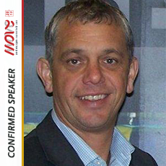**Kerry McDonald** has over 20 years experience in the sports industry in the UK. Kerry is a founder member of the group that established the award winning national charity StreetGames in 2006. StreetGames is now the leading national sports organisation in the UK for developing sport for deprived communities. StreetGames has grown to 250 projects, reached over 2 million attendances in youth sport, recognised as a national partner to Sport England, and secured sponsorship from Coca Cola and the Cooperative Group Ltd. Kerry is a member of the StreetGames senior management team leading on political advocacy, national partnerships, business development and fundraising.

Kerry is a specialist in the field of sport and regeneration, with a wide portfolio of capital projects, fund raising appeals, and capacity building programmes.  He was previously senior manager for Sport England for over 10 years. He led Sport England’s work in the West Midlands on social inclusion and community development. Kerry also managed investment in over 50 major capital projects whilst with Sport England, and has extensive experience in working with the local authority sector, schools and education sector, and governing bodies of sport. Kerry has also worked in the mainstream regeneration sector, leading the business development of a very successful regeneration company based in Birmingham, including design and delivery of complex capital projects and consultancy support to capacity build a large number of inner city organisations.

**Thursday 17.10.2013: Parallel Session 2 – Engaging socially disadvantaged groups in sport and physical activity**

**Niamh Murphy , Waterford Institute of Technology, Ireland and WHO Europe advisory group on physical activity promotion in socially disadvantaged groups, Germany**

**Promoting physical activity in socially disadvantaged groups: Outcomes from WHO’s PHAN project**

**Introduction**

Promoting physical activity in socially disadvantaged groups (SDG) is a challenge and guidance on good practice and policy formulation has recently been published as part of the WHO Physical Activity Networking (PHAN) project. Conclusions on good practice elements for HEPA promotion in SDG were based on (a) a review of existing evidence in Europe and elsewhere, (b) a compilation and analysis of case studies and (c) a review and analysis of national policies on physical activity.

**Methods**

A search of the European published and grey literature on physical activity and disadvantage produced data from all EU Member States but one (89 studies, and 6 review studies). A review of case studies targeting disadvantaged groups yielded 91 eligible projects and an in-depth review and analysis of 29 case studies from 9 member states was conducted. Good practice elements and recommendations for physical activity promotion were identified. A total of 121 policy documents on promoting physical activity were reviewed for coverage of specific actions relating to SDG.

**Results and Discussion**

In working with SDGs, how individuals are targeted and engaged, and how programmes are implemented is of the essence. More intensive support may be needed at all stages, which will be reflected by, for example, project time duration, funding and capacity-building needs. Both whole population and targeted approaches are advised. Evaluation was a notable challenge in the case studies and guidance is needed. In most countries there is no overt linkage of documents seeking to improve health in SDG through PA and/or sport to a wider spectrum of public policy, and key principles for policy formulation, targeted interventions, and research are outlined.

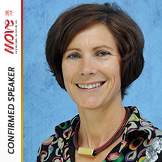**Niamh Murphy** has a background in physical education, and Masters and PhD specialisms in exercise physiology and health promotion. She works in the Centre for Health Behaviour Research in Waterford Institute of Technology, Ireland. She is an ex-international athlete, keen triathlete, cyclist and youth coach. As well as teaching, Niamh is involved at policy level in writing and implementing the physical activity guidelines and physical activity plan for Ireland. She collaborated in the EU “JoinIn” project on social inclusion and sport, co-ordinates the HEPA Europe working group on physical activity and social disadvantage, and participated in the advisory groups for the WHO PHAN project on promoting physical activity in socially disadvantaged groups. Peer reviewed publications include research work on the impact of mass events on population physical activity, and active travel promotion projects.

**Thursday 17.10.2013: Parallel Session 2 – Engaging socially disadvantaged groups in sport and physical activity**

**Kai Troll, Special Olympics Europe/Eurasia, Belgium**

**Special Olympics: Physical activity and social inclusion**

Special Olympics is the world’s largest organization that unleashes the human spirit through the transformative power and joy of sports everyday around the world. Through work in sports, health education and community building, Special Olympics is addressing inactivity, injustice, intolerance and social isolation by encouraging and empowering people with intellectual disabilities which leads to a more welcoming and inclusive society.

The movement has grown to more than 4 million athletes in 170 countries. With the support of more than one million coaches and volunteers, Special Olympics is able to deliver 32 Olympic-type sports and more than 53,000 competitions throughout the year, giving athletes continuing opportunities to develop physical fitness, demonstrate courage, experience joy and participate in a sharing of gifts, skills and friendship with their families, other Special Olympics athletes and the community.

Sports is a powerful force. It can shift the focus from disability to ability, from isolation to involvement. This changes attitudes and changes lives.

Despite significant progress, in many parts of the world people with disabilities are still denied their basic human rights, access to health care, inclusion in their communities and schools and denied the opportunity to reach their full potential.

Special Olympics advocates for ratification of the United Nations Convention on the Rights of Persons with Disabilities and aims to provide full implementation of the CRPD related to children and adults with intellectual disabilities, as well as conduct outreach and support to families, caregivers and communities.

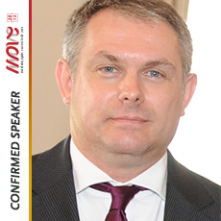**Kai Troll** is a social entrepreneur and Director of Strategic Development for Special Olympics in Europe/Eurasia. In this function he works with national boards and executive committees, guides and supports them in their strategic developments and facilitates growth of the Special Olympics organization within the region. Troll is also the Special Olympics representative to the UNOSDP and the IOC.

Previously, Troll was a Senior Management Consultant with the Boston Consulting Group. He served in different leadership roles of international organizations and non-profits in the area of Strategy, Organizational Development, Public, and Governmental Affairs and in Resource Development.

Troll has a BA in Science, a MBA in International Management and a doctoral degree in economical science.

**Thursday 17.10.2013: Parallel Session 2 – Engaging socially disadvantaged groups in sport and physical activity**

**Giovanni Capelli, University of Cassino and Southern Lazio from Italy**

**Physical Activities in Socially Disadvantaged groups: Lessons from the MOVE project**

In the MOVE project, partners had the opportunity to collect data on a considerable number of project activities, past or on-going, throughout many countries and sometimes from very different for cultural and social backgrounds. Together with all the MOVE project partners, a big effort was performed in building a data form capable of capturing not only the most easily “codeable” aspects of the practices (such as targets, methodology, funding, etc.) but which also aimed at avoiding the risk of losing the richness and complexity that grassroots sport clubs add in everyday practice.

While language barriers and methodological, social, cultural, political, financial differences are indeed issues to be faced, a very rich, varied and comprehensive picture of success practices in many different socially disadvantaged groups emerges from our collection.

We can synthetize our findings in three recommendations for policy makers and project managers:

1. Adapt yourself, take a multidisciplinary approach and be flexible
2. Strike a good balance the eagerness for participation, the attractiveness of competition and the opportunity for education
3. Care about your communities, your stakeholders and your methodology

**C:\Users\Saska\Dropbox\MOVE Congress 2013\Speakers\Giovanni Capelli.tiff**

**Giovanni Capelli** is Full Professor of Hygiene and Public Health at the University of Cassino and Southern Lazio, Italy. He has been Dean of the Faculty of Sport Sciences in the same University until 2012. His main research interests lie in analysis of Epidemiological data and in Health Promotion through Physical activity and Sport. He coordinates the University of Cassino Unit in the MOVE project.

**Thursday 17.10.2013: Workshop 1 – Communication campaigns and social media context; challenge and opportunity for sport organisations**

**Halli Kristinsson, Lazy Town,UK**

**How to entertain children to reach healthy lifestyles in a positive and catching way? LazyTown concept**

**About LazyTown**

Acquired by Turner Broadcasting in 2011, LazyTown is a leading and highly respected children’s entertainment brand comprising **award-winning TV series, live shows, sports events, publishing and more** that promotes health and wellbeing to pre-schoolers in an energetic and fun way. Created by its Icelandic star, former athlete Magnus Scheving, the programme has been broadcast in 170 countries, reaching over 500 million homes and in over 30 languages.

The LazyTown Motivational Campaigns is a grassroots program for 2-7 year olds designed to help promote a healthy lifestyle by encouraging kids to make healthier choices by taking the concept of health and turning it into a game.  LazyTown has collaborated with various government agencies worldwide on implementing these far-reaching and impactful health campaigns and has aligned with like-minded organisations such as Change4Life in the UK, “Elive Vivir Sano” with First Lady Cecilia Morel in Chile and Michelle Obama´s Lets Move campaign in the US.

**Thursday 17.10.2013: Workshop 1 – Communication campaigns and social media context; challenge and opportunity for sport organisations**

**Jacob Holst Mouritzen, ADVICE A/S, Denmark**

**International community management – organizing for impact**

Social media has been the talk of the town for the past few years. Since it's breakthrough it has had a tremendous impact on the possibilities for NGO's and non-profit organizations, as well as individuals to create awareness, and start a movement for a cause. With the click of a mouse we can reach thousands and even millions of users with our messages, without spending our entire budget. The problem is, most of us don’t.

During this speech Jacob Holst Mouritzen will talk about the possibilities for organisations to create international awareness as well as organising your social media efforts to maximise the chances of success and impact.

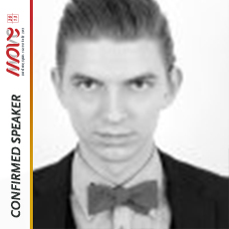**Jacob Holst Mouritzen** is a social media consultant for Advice A/S who work with network communications. He has been working with social media both strategically and hands on for more than four years, and has a broad range of experience with political campaigns as well as marketing, branding and public-change efforts.

He has been in charge of several succesfull international social media campaigns, and has worked on campaigns for The Red Cross, the Danish Youth Council, Ambassadors for Dialogue, Lukas Graham and the Now We Move campaign.

**Thursday 17.10: Workshop 1 - Communication campaigns and social media context; challenge and opportunity for sport organisations**

**Xavier Frocadell, Bcnpress Communication, Spain**

**The impact of social media on sport**

The figure of somebody who has the ability to affect our society has always existed in different sociocultural standards. This role is associated nowadays to the different social networks, especially Facebook or Twitter. The opinion of the market about our products is a reality. As a result of this opinion and as professionals of services and sports management we can’t avoid this reality. It’s necessary to incorporate this media to our strategic communication and marketing plans.

The communication with our market has become bidirectional. In this scene brands have to show their values and presence in the digital environment for keeping a global communication with the whole audience: customers, influential people, leads, etcetera.

The content of our messages in the different social platforms should lead the conversation to a highest level. Business relationships between our service companies and sports clubs have to keep a social correspondence to allow a good interaction between us and our audience or market.

To align the brand with the digital image and communication is not an easy task, but is completely necessary nowadays. Market demands more interaction, the existing information requires the presence of influential people who carry out the brand experience in digital environments to a definite way for users, customers and leads. To transcend limitations of paradigm change, this has to be broken for reaching the users and customers. We only can achieve this if we become more digitals and we interact in an efficient way with our market.

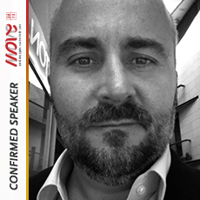**Xavier Forcadell**

Diploma in Business Studies, Degree in Market Research and Techniques, Master in Sports Management and Direction.

Xavier started with online marketing sector in 2006. Till then rediscovered himself every day and has achieved one of his goals: to turn his job into a unique personal experience. He works as Online Marketing Manager in Bcnpress at the moment. Bcnpress is a 360º communications agency. He develops online marketing projects for companies of different sectors: Account Manager, Web, SEO and SEM Development Specialist; Social Media Strategist, Online Content Manager, Easypress.es Product Manager,Content Marketing Manag. Commerce, Teacher.

He has been working in Sports Sector for more than 20 years. In the last years in sports facilities technical management.

His motivation is to achieve communication and interaction between brands and markets in online environment.

**Thursday 17.10.2013: Workshop 2 - Human Capital of new professionals/volunteers in sport**

**Expected characteristics of the human resources in sport for all organisations**

Four main ideas will structure our presentation:

* Firstly remember that voluntary sport associations promote specific social relations based on active contribution to a common project. All members are co-producers of the activities and co-responsible of the organization which supports them. This makes a clear difference with the for-profit organizations dealing with “clients” and with the public organizations dealing with “users”. That specific situation where members are co-producers of the activities and not receiving/consuming passively services delivered by professionals is a key dimension to understand the positions of the different human resources present in those organizations, members, volunteers and professionals…
* Secondly, consider that the quality of the activities produced by voluntary sport associations is mainly the result of the collective competences present in the organization. More than any others voluntary organizations are “learning communities” which means that sharing and organizing the transmission of knowledge, skills and competences are a major issue between members.
* Thirdly that the differences of statutes between paid staff, volunteers having specific responsibilities or “basic” members must not let them forget that they are all concerned by the achievement of the activity. If paid staff members are generally more available and systematically trained, their legitimacy is to be effective contributors to the common project. Volunteers undertaking specific tasks for the organization have also a crucial role, but it is more and more the case that their commitment is limited in time. They have to consider that they are firstly member
* Fourth and last point, the common project of the association is specific to the members interests. Associations are supposed to work bottom up, which is not always the case for sport organizations even in the area of sport for all.

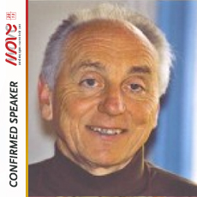**Jean Camy is** Professor (Emeritus) at the University of Lyon(PhD in Sociology; Habilitation in Sport Sciences)

Main activities undertaken at European level:

-Founding president of the European Network of Sport Sciences in Higher Education (ENSSEE), 1989-1993.

-Founding member of the European Association of Sport Management (EASM).

-Team leader, Vocasport project and report (2004)

<http://ec.europa.eu/sport/library/documents/c6/doc356_en.pdf>

-Founding member of the European College of Sport Sciences (ECSS) 1995-present

-Founding president (and honorary member) of the European Observatory of Sport and Employment (EOSE) 1993-present.

Activities undertaken at international level in the voluntary sport sector:

-Member of the Olympic Solidarity steering group, in charge of the development of the Advanced Sport Management Course programme and of the “Olympic Management Learning Community” (2004-present).

-Participation in the ISCA “European Volunteering Network” project (2011-present).

**Thursday 17.10.2013: Workshop 2 - Human Capital of new professionals/volunteers in sport**

**Thierry Zintz, EOSE, Belgium**

**How to promote a dialogue and a strong link between employment, education and training at the regional, national and European level between all key stakeholders of the Sport and Active Leisure sector?**

“Changes – Opportunities – Innovation”, the MOVE Congress 2013’s keywords could be well applied to the sport and active leisure sector.

Driven by volunteers, the Sport and Active Leisure sector is a people facing sector where a skilled and qualified workforce (paid staff and volunteers), from the grassroots level to the high performance end of the spectrum, is paramount to its success.

As a growing and promising sector, it must adapt and evolve to meet its potential as a major contributor to society (impact on economic, health and social inclusion) while delivering new and different opportunities for everyone to participate in sport and physical activity.

This should be done while taking into account three specific challenges regarding education and employment:

* Courses and qualifications are often not regarded as appropriate by sport organisations;
* The sector is fragmented and there is a poor communication and cooperation between stakeholders;
* Sport training often sits outside national qualification structure in many countries.

In response to these challenges, EOSE has developed an approach entitled Lifelong Learning Strategy for the Sport sector (or 7 steps model) to understand the realities of the labour market, facilitate the link between the worlds of education and employment, equip the workforce with the right skills, and improve the recognition of competences and qualifications.

This innovative Strategy has been designed to be flexible and can be applied consistently to the sector as a whole, a sub-sector, an individual sport, a specific occupation etc.

The presentation that will be delivered at the MOVE Congress by EOSE will aim to introduce the 7 steps Model as a solution to the current challenges and an approach that could be well-adapted to the grassroots level.

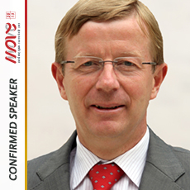**Thierry Zintz** – EOSE President

Since 2005 **Thierry Zintz** is a professor of Sports Organisations Management at the Faculty of Sports Sciences of the Université catholique de Louvain, Belgium. He is the Dean of the Faculty since February, 23, 2010. He is in charge of the Olympic Chair Henri de Baillet Latour – Jacques Rogge in Management of Sport Organisations at the same university. In this framework, he works closely with the Louvain School of Management as a senior researcher and member of the Center for Research in Entrepreneurial Change and Innovation Strategies (CRECIS). He holds a PhD from the University of Louvain in 2004 with a thesis on change management in European National Sports Governing Bodies. He is also Vice-President of the Belgian Olympic and Interfederal Committee since 2001 and Secretary General of the European Observatory of Sport and Employment (EOSE). Since May 2010, he is the director of the MEMOS in English and coordinator of MEMOS (English, French and Spanish versions). The MEMOS is an Executive Master in Management of Sport organisations, organised by the International Olympic Committee and twelve universities in the world.

**Thursday 17.10.2013: Workshop 2 - Human Capital of new professionals/volunteers in sport**

**Joan Sunet,Voluntaris 2000, Barcelona, Spain**

**Voluntaris 2000 - we serve community**

Voluntaris 2000 is a non -profit organization created with the desire to extent the illusion of voluntary movement, born in the aftermath of the Barcelona Olympic Games in 1992 . We made our first public appearance right after the Games, during the Festivity of La Mercè the same year.

We are a group of people who promote the excitement and enthusiasm of all types of volunteer purposes: recreational, social, cultural, civil, sporting and environmental, with all that implies:  teamwork, effort, solidarity, commitment, respect for others, responsibility.

Promote knowledge and appreciation towards our city and its citizens through active participation in different events and activities, and we encourage people to show a more civic behavior, and thus, improve quality of life.

We organize, collaborate and help in preparing and conducting all kinds of sporting, cultural, environmental, recreational and civic events, with no bond with any organization.  In this way, volunteers build up a curriculum that makes them experts in the field of volunteerism and non-profit associations.

Voluntaris 2000 has been evolving as an association, increasingly more involved in city events in Barcelona widely noted for its skill in the management and mobilization volunteers.

Voluntaris 2000 is proud to contribute to the welfare of the city.

**Thursday 17.10.2013: Workshop 3 - Outdoor activities and new profile of participants in physical activity**

**Raimonds Elbakjans, Ghetto Games, Latvia**

**Ghetto games - Example from Latvia**

**Ghetto Games history:** Ghetto Games movement dates back to the times of recent global economic crisis. It was founded in one of the most disadvantaged areas of Riga - Grizinkalns when the recession was at its’ highest point in Latvia. Grizinkalns has historically been a place where the working class lived their lives and raised their children. Because of the economic recession lots of people lost their jobs, which was a good reason to start doing things that we love. It was a time when the depressed minds of those left unemployed were able to be saved by sports. Democratic kinds of sports activities that do not require a lot of money: street basketball, street workout, street dance, football and others. During these hard times, peoples’ good will and help from any outside sponsors were two separate things that somehow could not find a way to collaborate. Poor children running in the streets of Grizinkalns with nothing to do, an area full of alcoholics and prostitutes. No doubt Grizinkalns was something of a ghetto. The only difference is that our Ghetto does not degrade one’s self, it gives us will to raise above!

Currently **Ghetto Games** is the largest street sports and culture platform in Latvia where young people are to express themselves, develop their personalities - grow physically, morally and creatively, creating a healthy society and a good environment. We are involved in sports, music, art, videos and many other areas. Every year we organize an average of 70 different events in street basketball, street football, basketball, street floorball, streetbike freestyle, BMX freestyle, MTB freestyle, skateboarding, inline skating, street rugby, street dance, street gymnastics, armwrestling, bike trials, wakeboarding, etc.

10 500 people participated in the 2013 Ghetto Games season activities. Our audience has currently grown up to 50 000 followers.

**Ghetto Family** is a group of friends and individual producers who other than Ghetto Games social business work on various commercial activities to help achieve the overall Ghetto Games mission and goals: Ghetto Events, Ghetto Burger, GhettoTV, Ghetto Rent, Ghetto Art & Lakshe Passion. 

Ghetto Family values the social dimension as of great importance, because we care about the growth of young people. During the five years of the organizations existence Ghetto Family leader Raimonds Elbakjans and his colleagues regularly visit schools all over Latvia, as well as a juvenile correctional institution in Cesis city. This is done to share their experience on life, career, motivation and the power of positive thought as well as other important subjects to young people. During year 2013 the program Ghetto Cares was commenced, in which all summer long for each and every day free workshops for young people were provided on street basketball , street workout, street floorball, street dance, etc.

At the beginning of 2013 we realized that we, as young people with our own organization are able to help our neighborhood, so we started the project , "I'm a patriot of Grīziņkalns" whose purpose is to promote the growth of the neighborhood of Grīziņkalns , develop patriotism to current residents and improve the image of the neighborhood , making it a sporty , positive and active place to reside.

70 events each year is the perfect platform to engage young people in voluntary work, where they have the opportunity to learn responsibility towards all kinds of work and their colleagues and many other qualities that serve them far in life. Hard working and talented young people have the opportunity to join the Ghetto Family as professional event coordinators and organizers.

**Thursday 17.10.2013: Workshop 3 - Outdoor activities and new profile of participants in physical activity**

**Karin Creavin & Steve Bedser, BE Active, Birmingham,UK**

**Be Active**

The Be Active scheme in Birmingham has been running since September 2009. There are now over 390,000 people on the scheme. The scheme offers free physical activity sessions to all residents of Birmingham. Activities include swimming, fitness classes, and the gym within local leisure centres, as well as organised activities in local parks such as tennis, Zumba, Tai Chi, running, walking and cycling.

The scheme has won 15 national and international awards, and demonstrates immense value for money. Independent evaluation of the scheme has shown that for every £1.00 invested in it, there are £21.30 worth of savings to the system, with the bulk of savings being realised in the health sector. The scheme has also demonstrated immense success in targeting the most deprived and vulnerable in society, while providing a universal offer for all citizens.

The scheme has now been expanded into the city’s parks and next year will see the launch of 50 ‘active parks’ with a range of outreach healthy activities happening at a local level.

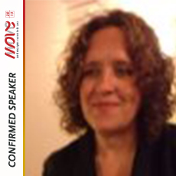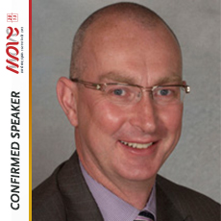

**Thursday 17.10.2013: Workshop 3 - Outdoor activities and new profile of participants in physical activity**

**Veronica Reynolds, Intelligent health, UK**

**How new technology can create walking and other activity schemes to help large numbers of people get moving again?**

**Activating a whole community – Beat the Street Caversham**

It has been suggested that walking is 'the perfect exercise'. It is accessible to nearly everyone, free of cost, low impact and low risk. Studies have shown it to be effective in reducing the risk of many chronic illnesses from cardiovascular disease to depression. Physical activity projects aimed at improving health are typically targeted at segments of a community. Beat the Street is a walking project that activated a whole community using the latest innovation in walking technology – the 'walk tracking unit' or 'beat box'.

This project builds on Intelligent Health’s Beat the Street Global School Walking Challenge. BTS Caversham however, involves the whole community and reached out to the 30,000 residents of Caversham, inviting them to take part in a competition to get active. The project was promoted through schools, GP surgeries, local business and community groups.

Over three months from June to September 2013, 5491 people took part in the project (approx. 20% of the population), collectively achieving an estimated total distance covered of 50,000 miles (or 80,000 kms) .

The main motivations reported by people for taking part included ‘having fun’ and ‘winning points’.

In addition, people 67% reported walking more as a result of Beat the Street and 80% said they would continue with the changes they had made to the way they get around**.**

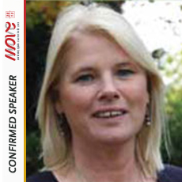**Veronica Reynolds** has over 20 years’ experience in exercise, health and psychology with a special interest in walking projects. A former director of Walk England and trustee of Living Streets, she has five years’ experience in developing and delivering training for the National Walking for Health initiative. At Intelligent Health she is Project Director for the global Beat the Street walking challenge and GP Training projects.

**Thursday 17.10.2013: Closing of the Day - Sport`s Impact on the Economy**

**Günther Grohall, SportsEconAustria, Austria**

**Study on the Contribution of Sport to Economic Growth and Employment in the EU**

Sport appears only in a tiny niche within the System of National Accounts. In standard Input-Output-Tables it was and still is aggregated with other activities. Even more, only a few topics of sport are covered in this niche like promotion or operation of sport facilities. Therefore specialised Input-Output-Tables: Sport are calculated (also often called “Sport Satellite Accounts”) to filter sport-related activities out of all other sectors of the System of National Accounts. This is usually done on a national level. To calculate the respective values for the EU we gathered/prepared national Sport Satellite Accounts from all at the time 27 EU member states and combined them in a Multiregional Input-Output-Table:Sport. By doing so, not only the mere size of sport in the EU in economic terms could be measured for the first time. The interlinkages between sport and non-sport sectors all over Europe became visible thus inter alia allowing calculations of indirect effects (impact on the supply chain).

According to the System of National Accounts, sport in Europe creates only around 0.3% of total employment in the EU. Using the above method we could show that in reality this value is as high as 2.1%. Results for different countries, however, can deviate a lot from EU-wide averages. Such differences were used for further analyses on how sport and GDP correlate.

Additional indicators were calculated e.g. to identify key sectors or show the range of sport-related goods and services produced in a nation.

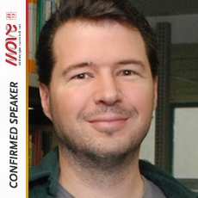

After his academic and post-graduate education in business administration, economics finance, and computer science Günther Grohall has been working in the wide field of applied economics since 2002. As of 2007 he is employed at SportsEconAustria researching the different aspects of sports and economics in the EU focussing on Austria. Topics there span a range from regional impacts of alpine infrastructure to EU-wide impacts of sport in total. He usually uses numerical, computer-based methods, analytical models, as well as inductive statistics and time series analysis.

**Thursday 17.10.2013: Closing of the Day - Sport`s Impact on the Economy**

**Simon Cooper, GLA Greather London Authority, UK**

**A Sporting Future for London**

Published in Spring 2009, *‘A Sporting Future for London’* set out how the Mayor intended to develop a grassroots sports programme, the aim of which was to help secure an increase in participation in sport and physical activity amongst Londoners and create a sporting legacy for London from the 2012 Olympic and Paralympic Games.

It also set out how the sports programme would facilitate wider social outcomes in London, such as improving health, social cohesion and educational development and tackling crime.

The programme is designed to tackle barriers to participation and addresses issues relating to the supply side (facilities, coaches, etc.) and the demand side (projects aimed at stimulating demand).

The programme has a particular focus on getting ‘inactive’ people and more disabled people into sport and physical activity.

A Sports Legacy Fund was established to deliver the programme. To date, the Mayor’s investment has been £22.5m (€27m). A similar amount of money has been provided in the form of matched funding. So far, this has funded:

* 80 sports facilities in London;
* Over 13,000 sports coaches and officials; and
* Projects offering participation in a wide range of different sports, traditional and non-traditional.

*‘A Sporting Future for London’* also included an aim to bring together more closely those organisations working in grassroots sport in London so that they work in a more collaborative and strategic way on policy and funding matters.

To oversee all this, the Mayor established the London Community Sports Board, chaired by a London Member of Parliament and former Minister for Sport (Kate Hoey MP).

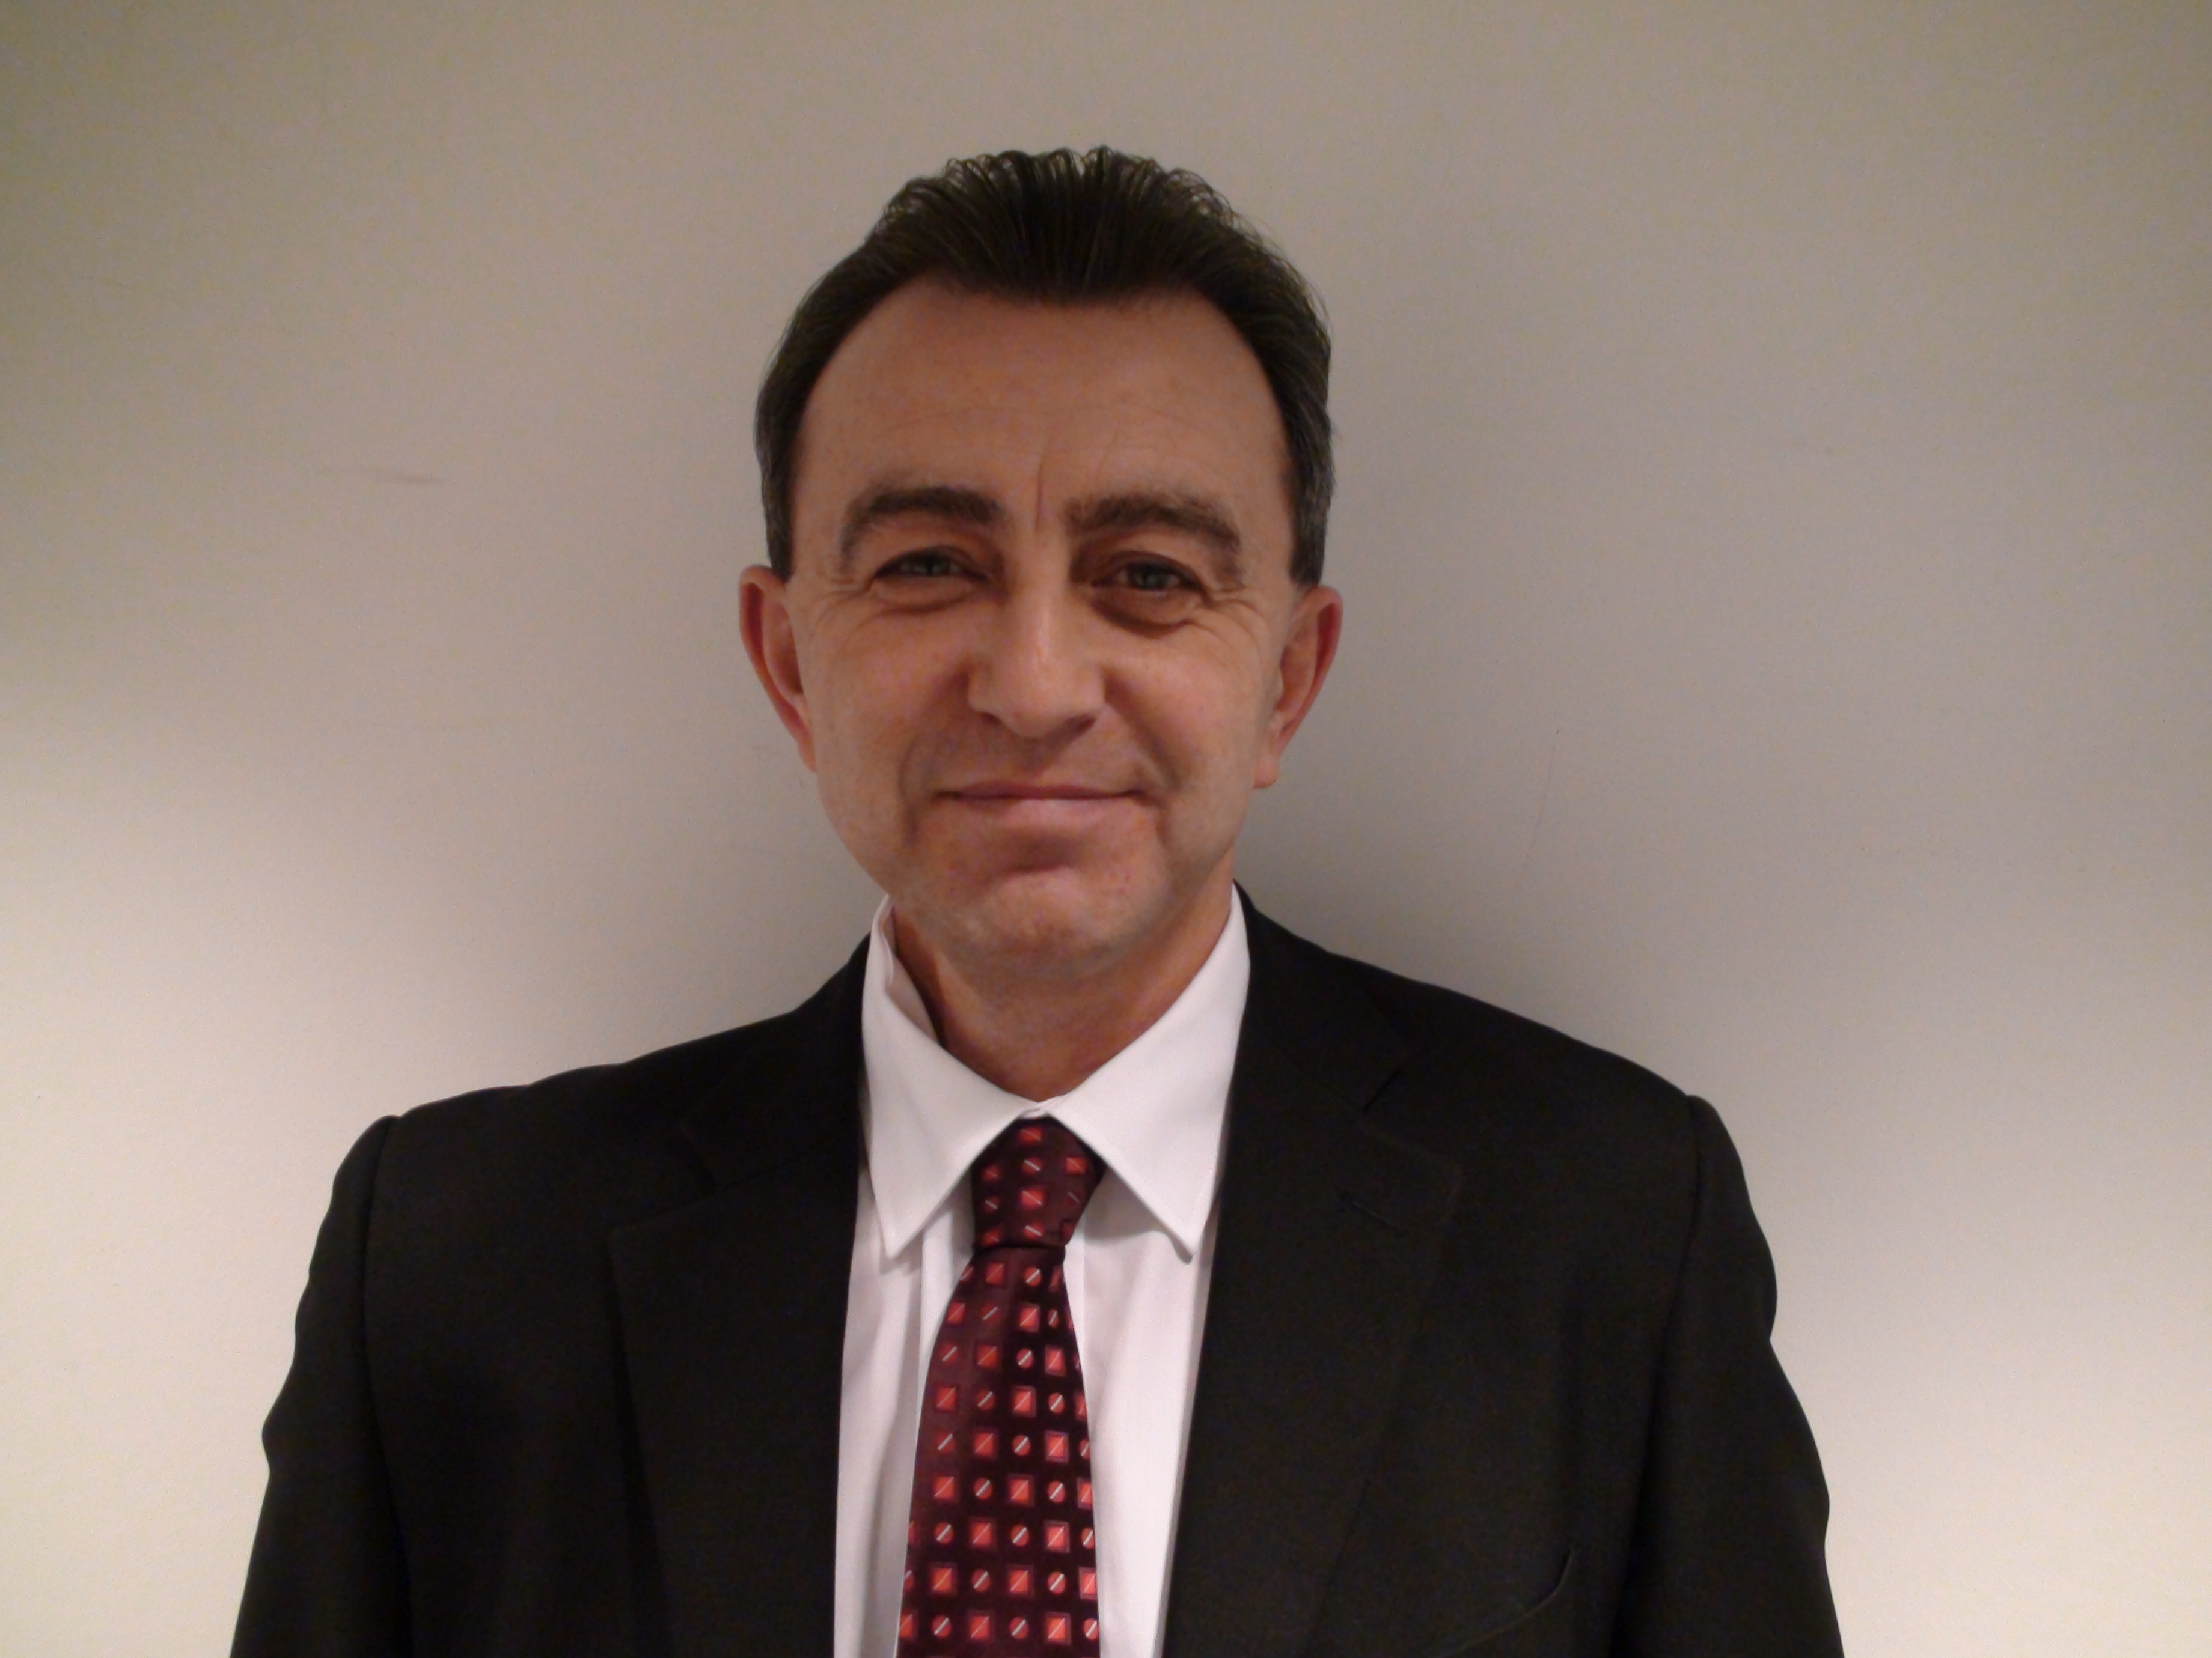**Simon Cooper** is head of the Greater London Authority’s Sport Unit, which was established in 2008 to set up the Mayor of London’s Sports Legacy Fund - the Mayor’s contribution to deliver the sporting legacy from the 2012 Olympic and Paralympic Games.

Since then, the Fund has invested several million pounds in grassroots sports projects across London.

Simon is a former civil servant and worked for a number of Government Departments. In 1997 he joined the Department for Culture Media and Sport (DCMS) where he worked on Government sports policy and in the Private Office of the then Minister for Sport.

In 2002 he was seconded to the Prime Minister's Strategy Unit as part of the team that wrote the Government policy document on sport and physical activity*, 'Game Plan'*.

**Thursday 17.10.2013: Closing of the day: Sport`s Impact on the Economy**

**Prof. Dr. Christoph Breuer, Deutsche Sporthochschule Köln, Germany**

**Sport`s Impact on the Economy - Experience from Germany**

No doubt, sport in general and sport-for-all in particular are important cultural assets. However, sport is also of economic significance. Latest research shows that almost 4 % of Germany’s GDP is sport-induced (Ahlert, 2013). Moreover, the sport related labor market grows. 80 % of Germany’s sport-related GDP are attributed to sports-for-all. A new study shows clearly that sport cannot be any longer just seen as a public expense (Pawlowski & Breuer, 2012): Sport-related tax revenues are much higher than public spendings for sport. As a consequence thereof sport has to be revaluated from a fiscal point of view. Taking the narrow Vilnius definition of sport tax revenues in Germany amount to € 14.7bn. € whereas public costs (expenses plus lost tax revenues due to tax exemptions) mount up to € 9.9bn €. Taking the broad Vilnius definition of sport tax revenues amount to 22.2bn € whereas public costs mount up to 9,9bn €.

Thereby, it has to be taken into consideration that some of the most important economic effects of sport for all are not captured by standard tools of economic statistics like national accounts or GDP: the value of voluntary work and the sport-induced impact on public health, social integration and human capital. The added value created just by voluntary work in sports-for-all mounts up to € 7bn (€ 6.7bn in grassroots sports clubs and € 350m in sports federations; Breuer 2011, 2013). Thus, all the efforts we see in many countries to set up a sport specific national satellite accounts are important. However, it may not overseen that a valid valuation of sport’s economic value has to take also those creations of value into account which are not captured by the standard tools of economic statistics.

References:

Ahlert, G. (2013). *Die ökonomische Bedeutung des Sports in Deutschland. Ergebnisse des Sportsatellitenkontos 2008*.

Breuer, C. (ed.) (2011). *Sport Development Report 2009/2010. Analysis of the sports clubs’ situation in Germany. Abbreviated version.* Köln: Sportverlag Strauß.

Breuer, C. (ed.) (2013). *Sportverbände, Sportvereine und ausgewählte Sportarten. Weiterführende Analysen der Sportentwicklungsberichte.* Köln: Sportverlag Strauß.

Pawlowski, T. & Breuer, C. (2012). *Die finanzpolitische Bedeutung des Sports in Deutschland.* Wiesbaden: Springer/Gabler.

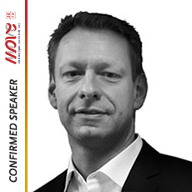 **Prof. Dr. Christoph Breuer** is full professor at German Sport University Cologne and director of the Institute of Sport Economics and Sport Management. From 2006 to 2011 he was simultaneously Research Professor at German Institute of Economic Research (DIW Berlin). Dr. Breuer publishes widely in economic A-Journals as well as in leading sports economics and sport management journals such as Applied Economics, Journal of Sport Economics, Journal of Sport Management, International Journal of Sport Finance, Sport Management Review, European Sport Management Quarterly, Voluntas, Nonprofit and Voluntary Sector Quarterly. Dr Breuer’s main research fields are (1) sport systems research, (2) sport finance and (3) sponsoring research. Dr. Breuer is member of the World Anti-Doping Agency (WADA) Finance and Administration Committee. Moreover, he is founding member of the European Sports Economics Association.

**Thursday 17.10.2013: Closing of the day: Sport`s Impact on the Economy**

**Dave Newton, NOVA Inspiring events, UK**

**How NOVA creates challenging events which generate significant local economic impact and have local and national political support?**

Great Run events are now staged across the UK, all based on the template of the Bupa Great North Run. As major mass participation events that are televised on national and international TV, they attract a large number of visitors as well as a growing TV and on-line audience. The Bupa Great North Run with 56,000 entries generates over £22m economic impact to the local economy as well as the social impact of promoting participation.

Nova is currently looking at how the framework around the events can be developed to increase the depth and scope of both the social and economic impact.

Clearly the event sits at the end of a customer journey which starts when the participant decides on their challenge and enters. It is the development of this journey that can increase the social and economic benefits through structured, personalised interaction with the customer. David will discuss how Nova is mapping this journey and building the interactions at key “touch points”. These interactions are being delivered on-line through training and preparation and also in the community through “Great Run Local”, local weekly running events.

By collecting and collating data from all these interactions Nova is building a large behavioural database which currently has over 1.3 million customer records. This data is enabling the business to further personalise its interaction with the customer as they prepare for their challenge and at the same time build the social and economic impact of the event.

David is originally from Newcastle and spent his early years living in the city before leaving in 1978 to complete a degree in Biology at Birmingham University.

After graduating he took up a position in teaching before moving to the commercial sector as a Business Development Manager for Procter & Gamble.

During his career David maintained an interest in sport, so in 2002 when Brendan Foster asked him to join Nova he readily took up the offer.

In his role as Managing Director, he has worked with Brendan to develop Great Run, a year round running programme with over 273,000 participants. More recently swimming and cycling have been added, with the series now established as the world's biggest mass participation programme.

As well as international development new technology will be a key strategy and David is working with a range of partners to develop this area around the core programme.

**Friday 18.10.2013: Opening of the day - Experience from innovative partnerships in sport**

**Lenna Knorr, City of Stuttgart and Juliane Schlindwein, STB, Germany**

**Innovative offers and programmes for physical activity as results of partnerships**

**Changes**

For many years the STB and the Department for Sports and Physical Activity of the State Capital Stuttgart connects a deep, grown partnership.

Societal changes influence the functions and focuses of both institutions. The traditional club-related sports culture was extended by more and more providers and non-organised activities in the field of fitness and health. The physical activity promotion of all Stuttgart citizens has become one of the most important tasks. This includes e. g. the local sports development, various sports programmes, sports events and sports facilities.

**Opportunities**

Both organisations have their particular strengths. While developing new programmes we are taking into account this particular power. The fields of cooperation are very wide, starting with qualification of trainers, continuing with quality assurance and the implementation of programmes.

**Innovation**

We would like to present exemplary four fields of our partnership:

1. **„kitafit“**

· Programme to promote children‘s physical activity in the setting kindergarten

· Qualification of trainers and educators in cooperation between STB and Sports Administration

2. **Local networks**

· Sports development networks in all districts of Stuttgart

· Thematical district approach 🡪 information setting

· City wide round tables

3. **Gymwelt campaign**

· The brand GYMWELT includes the various offers in the field of gymnastics and fitness in sports clubs

· Support Stuttgart´s sports clubs with consulting, advertising efforts and different events to show their range of services

· „Sport in the park“; offer possibilities to Stuttgart´s citizens for daily moving (especially in sports clubs) as a part of the campaign in Stuttgart

4. **„Fit ab 50“**

· Programme focusing on the needs of physical activity among older people

· HEPA Framework for other European Cities

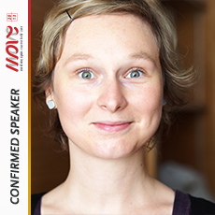

**Lena Knorr**

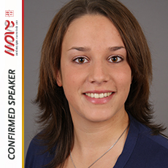Sports and Physical Activity Department of the state capital Stuttgart in the field of Sports and Physical activity promotion and sports development; coordination of networks to promote physical activity on local, district, city-wide and European level („Cities for sports“): implemenation of several programmes, e.g. „Sports in the park“; graduate in public management sciences.

**Juliane Schlindwein**

Swabian Gymnastics Federation in the field of fitness, gymnastics and „sports for all“; responsible for sports clubs in the region of Stuttgart: consultation of sports clubs, cooperation and networking with partners in Stuttgart, implementation of programmes in the field of fitness and health; graduate in health care management.

**Friday 18.10.2013: Parallel Session 3 – Sport Facility Management**

**Aleksandra Goldys, Social Action Warsaw University, Think Tank for Sport, Poland**

**Sport infrastructure as the common good - different models of management in Poland: present situation and future possibilities**

The sports infrastructure is often the point of departure for thinking about sport. But too often it is also the end of it. Buildings and facilities are deemed necessary condition for physical activity. In Poland the situation is quite paradoxical: six years ago the Polish government decided to build a small sport complex (so-called Orlik) in every single community – and succeeded! At the same time people seem to prefer activities outside the “buildings” and beyond traditional sport clubs: they want to run, ride a bike or train Nordic walking in open public spaces, such as parks and forests.

Why do we need infrastructure? When does it fulfill its role?

The research on Orlik program shows that:

* Sport infrastructure should be treated as multifunctional space and, at the same time, every space should be considered potentially “sporty”.
* Focus should be on soft and management skills of coaches (promotion, engaging different groups, cooperation with local NGOs, using new technology).
* The infrastructure should be managed locally and in connection with other local institutions.
* Focus should be on investing in bottom-up research in order to understand people habits (in specific local context), as well as in design thinking (using design in popularization of sport. We should remember that the contact with infrastructure comes down to bodily/sensual experience.

The preliminary conclusion is that the sports infrastructure should have a host, not an owner, and that it should be managed with the use of participatory techniques.

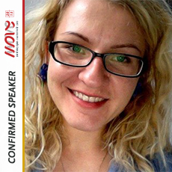**Aleksandra Gołdys** works at Warsaw University in Social Action Project, which is dedicated to social change through sport for all. Researcher and facilitator in different processes, e.g. inter-sectoral group preparing new vision of sport volunteer before UEFA EURO 2012TM, evaluation of official social programs during UEFA EURO 2012 TM; expert of the Ministry of Sport and Tourism responsible for research on national training program for sport coaches; coordinator in the first consultation project on the development of the National Stadium in Warsaw. Privately – for ten years was a dancer (the thickest in the team but very fiercely training).

**Friday 18.10.2013: Parallel Session 3 - Sport Facility Management**

**Joze Jensterle, IASLIM, Slovenia**

**Future of sport, leisure and infrastructure: Changes. Opportunities. Innovations.**

**Changes**

World is changing. Natural environment and urbanization are changing. Politics, professions and economics will design »playness culture« as new philosophy or paradigm for changing culture of physical activity in socio-economical development of local communities towards social welfare state. New culture will encompass sustainable development, social management, green technologies and innovative programs. New systems of public-private partnership and new concepts in planning, building and managing of sport and leisure infrastructure, will be introduced.

**Opportunities**

Democratic societies are promoting social welfare states. Local communities have all ingredients for changes in sport, leisure and infrastructure. They have motivated, educated and trained people, professionals and volunteers in local associations. They have thousands of facilities in natural and urban environment. Entrepreneurs and corporations have technologies and financial sources to develop businesses and participate in realization of public needs through public-private partnership.

**Innovations**

Countries will introduce innovative national systems of education, sport for all, social management and infrastructure. Innovative physical education will be introduced in preschool and school programs. Sport and leisure will promote healthy lifestyle. Innovative social management concepts of sport and leisure programs and infrastructure will be introduced by professional and non-profit organizations. Future trends in development of sport and leisure infrastructure will be oriented in: (a) natural environment and outdoor areas and (b) reconstruction, renewal and modernisation of already build facilities. Local communities, associations, schools and entrepreneurs will develop innovative programs for all people, children, youth, women, disabled and elderly people, professionals and recreational sportsman. New types of community centres with accessible, safe and quality programs will emerge.

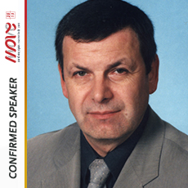**Jože Jenšterle** is General Manager of the IASLIM, International Association of Sport and Leisure Infrastructure Management, Director of the Sport Center Association of Slovenia and member of Slovenian Olympic Committee, Sport Infrastructure Committee.

He is economist and has special knowledge and professional experiences in project management and consulting, especially in the fields of education, marketing, sustainable development, social management, program development, tourism, investments, infrastructure for sport and leisure. He worked as Project Adviser for European Union PHARE programs and has Certificate of Business Management issued by JICA, Japan Government Agency in Tokyo. He had continuing professional development and training in the certified programs at the University of Florida in Gainesville, USA, University of Toronto in Toronto, Canada, The Australia Clinic in Perth, Australia, Danish College of Pharmacy Practice in Hillerød, Denmark, Babson College International Colloquium, Wellesley, USA, Universidad Católica de Chile in Santiago, Chile and CEGOS European Community PHARE programs for the managers.

Today he leads two major research & development projects: International school of sport and leisure infrastructure management and Standards and regulations of planning, building, managing, maintaining and usage of sport and leisure infrastructure.

**Friday 18.10.2013: Parallel Session 4 – Building capacity for health-enhancing physical activity promotion in socially disadvantaged groups**

**Alfred Rütten, Institute of Sports Science and Sport, Friedrich-Alexander-University Erlangen-Nuremberg, Germany**

**MOVE project: Building capacities to serve socially disadvantaged groups**

This presentation will outline how 15 MOVE Pilot Projects in 13 European Union countries are building capacities to promote health enhancing physical activity (HEPA) in socially disadvantaged groups. It will explain how good practices are being gathered and used to increase interest, raise awareness and foster participation in sport and HEPA.

Three good practices are the cornerstone of this project: networking, sustainability and quality management. An easy to follow framework that guides the implementation of these practices will be reviewed. The presentation will highlight how a new and innovative Internet forum is bringing practitioners from a variety of levels together to discuss the challenges and opportunities that sports organizations face when promoting HEPA – and how input from this forum will lead to an influential position paper that addresses these very issues.

The presentation will also focus on how stakeholder meetings that connect international project partners with local and regional partners are leading to cooperative and fruitful discussions. These discussions are addressing important topics such as how the sports sector can work more closely with the health sector and how existing programs can keep up with current trends in funding schemes.

HEPA promotion is one of the most promising approaches to preventing and reducing diseases associated with sedentary lifestyles. Such diseases affect the wellbeing and productivity of millions of EU citizens; those from disadvantaged groups can be even more susceptible. All MOVE pilot projects and activities are designed to work together to achieve more successful integration of HEPA into the lives of individuals and communities.

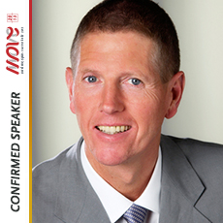**Alfred Rütten** is the director of the Institute of Sports Science and Sport at Friedrich-Alexander-University Erlangen-Nuremberg, Germany. Prof. Rütten has led several cross-national research projects on physical activity surveillance and health promotion in the European Union. He coordinated the EU funded “European Network for Action on Physical Activity and Ageing (EUNAAPA)” project and led the EU funded projects “Improving Infrastructures for Leisure-Time Physical Activity in the Local Arena – Good Practice in Europe (IMPALA)” and ”Building Policy Capacities for Health Promotion through Physical Activity among Sedentary Older People (PASEO)”.  He currently leads several activities in the MOVE Project in cooperation with the International Sport and Culture Association - ISCA.  He was one of the experts that developed and is working to implement the “European Physical Activity Guidelines” of the European Commission (2008). Since 2010 he has been part of the WHO Expert group on “Physical Activity Promotion in Socially Disadvantaged Groups”.

**Friday 18.10.2013: Parallel Session 4 - Building capacity for health-enhancing physical activity promotion in socially disadvantaged groups**

**Rizwan Aboo, Street League, United Kingdom**

**Street League MOVE Academies: Change Lives through Football**

Street League will run four 8-weeks Academies, renamed "The MOVE Academies" from October 2012 to September 2013.  The MOVE Academies will be delivered by the South-East London Coach and Progression Coordinator who will deliver fitness and football training, qualifications and 1:1 progression support to 20 participants on each Academy.

The aim of the project is to develop the recording and tracking of fitness outcomes and soft skills linked to participation in Sport in order to assess the impact of these on the achievement of "Progression Milestones" and "Hard Outcomes". Our argument is that a fitter and healthier participant is more able to take positive choices and develop key soft and employability skills linked to participation in Sport such as time-keeping, discipline, being able to follow instructions, team work etc. As a consequence, it should be easier for a participant whose fitness level has improved to access the job market.

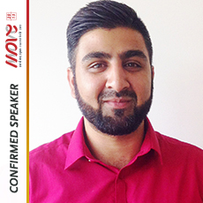**Rizwan Aboo** is from England, London and is currently working for Street League. He initially started to work in the football industry as a community coach for Charlton Athletic. His desire to help young people saw him move to Street League in 2004.

He has covered every delivery aspect of the project from an operations side, and has helped the organisation during a major restructure. Rizwan was responsible for designing, developing and implementing the new structure the organisation now embraces which is to deliver qualifications in line with the football element of the project. The success of this delivery model has allowed the organisation to gain credibility and funding from various funders/colleges and grants.

He was a Youth and Community Coach for 8 years until his recent promotion as the Employer Engagement Manager. This allows him to broker jobs for the young people who have come through the Street League Programme. He has over 8 years of football coaching experience, is a UEFA B Licenced coach and coaches on a voluntary basis at a Premier League Academy.

His work has seen him rub shoulders alongside high profile politicians, sports athletes and celebrities including David Cameron, Cesc Fabregas and Gerard Butler.

**Friday 18.10.2013: Parallel Session 4 - Building capacity for health-enhancing physical activity promotion in socially disadvantaged groups**

**Mihai Androhovici, Romanian Federation of Sport for All, Romania**

**Inter-ethnic Cup** **Bukovina**: **A model** **of social integration?**

Inter-ethnic Cup Bukovina is an annual event, now in its tenth edition. Its target groups are ethnic minorities living in the Bukovina region and surrounding areas in Romania, Ukraine and the Republic of Moldova.

The activities take place in two areas: sports and traditional culture. Sports activities include football, kin-ball, archery, table tennis, badminton whereas cultural activities include traditional songs and dances of ethnic minorities. These are represented both by Italians, Germans, Hungarians, Ukrainians, Russians, Poles, Armenians, Gypsies, Hebrew but also by guests of the Romanian communities in Ukraine and Moldova.

In the MOVE Project, pilot activities have been linked to including several new target groups:

* Young people from disadvantaged areas and former industrial areas. Here football championships were held for boys and girls.
* Mountain activities with young people from single-parent families or with a low income, but with good results at school.
* Young people in the evidence of the Probation Service of the Ministry of Justice or convicts in prisons. Here activities included archery, football and arm-wrestling.
* Immigrants from special residency centers. Here the activities involved were archery, football and cricket.

The development of this project has led to the creation of a new inter-institutional network of partners working to increase the number of activities among these young people, improving sports facilities but also their education in the spirit of fair play.

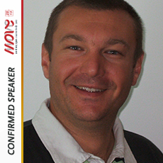**Mihai Androhovici** is a professor of Physical Education and Sport with a bachelor's and master's degree from the “Alexandru Ioan Cuza” University Iasi, Romania. He had been teaching this discipline at the high school level since 1998, when in 2005 he was delegated by the National Agency for Sport and the Romanian Government to lead the Suceava County Department of Sports as Director.

In his four years as Director, he was responsible for the organization of sport performance and sport for all. One of the main objectives was to decentralize the sports system by passing it from the state to the private sector. At the end of his mandate, he worked as a Sport Advisor to the Ministry of Youth and Sports in the Suceava region.

In 2009 he was elected as Vice President of the Romanian Sport for All Federation where he dealt with the Development Projects and Programs Commission. The objectives are related to increasing financing for Sport for All system, the number of affiliated organizations and volunteers. Mihai Androhovici was the coordinator of the team who drafted the Physical Education and Sports Encyclopedia at a regional level and collaborator for the national one.

**Friday 18.10.2013: Parallel Session 4 - Building capacity for health-enhancing physical activity promotion in socially disadvantaged groups**

**Gonçalo Sequeira dos Santos, Associação CAIS, Portugal**

**Futebol de Rua Project: Social integration of the homeless through access to sport**

Associação CAIS is an NGO founded in 1994 to support people suffering from extreme poverty and social exclusion, in particular those who are homeless. Besides two Centers in Lisbon and Oporto, it runs several projects, including the Futebol de Rua Project.

The Futebol de Rua Project is a social (through sports) project created to promote access to sports and social inclusion to those living in poverty and exclusion. It has been running since 2004 and is divided in 2 areas:

Access to Sport through the Futebol de Rua National Tournament which is a national and inclusive street football tournament.

Inclusion through sports: the main activities here include *The Move-te,* faz Acontecer (*move yourself, make it happen*), implemented in partnership with the National Plan for Ethic in Sports and the Youth in Action Agency in Portugal, which aims to empower the professionals and develop life skills in the participants of the project through the practice of street football. Another important activity is *Sessões Move* (*Move Sessions*), the pilot developed for the Move Project, which consists of street football training sessions with integrated life skills dynamics that are taking place twice a week for Lisbon participants, primarily in a situation of homelessness. This group is often marginalized, even in the Futebol de Rua Project, due their lack of sports skills. The pilot promotes access to a healthy lifestyle and allows participant to improve basic life skills that are fundamental to social inclusion.

More than numbers, with the pilot, the aim is to promote access to this very specific group. During 2013 the sessions already had 24 regular participants. The pilot project has become a priority and will be continued in 2014 with the support of the Portuguese Institute for Sports and Youth which recognized the importance of it from the very beginning.

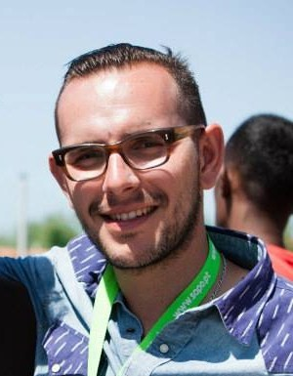**Gonçalo Sequeira dos Santos** was born in Lisbon in 1984, he graduated in the field of Rehabilitation and Social Integration in 2007 and soon after began working in the social field. After experiences working with different targets, he joined the Associação CAIS team in 2008 and has been working there since then.

Besides being in charge of case management, he has been the Coordinator of the Futebol de Rua Project since 2008, being responsible for developing all the national street football tournaments, training camps, participations in international competitions, including the Homeless World Cup and the European Street Football Festival and many other partnerships with the National Plan for Ethic in Sports, the Youth in Action Agency, among many other entities.

Over the years he has also had the opportunity to speak in different workshops and seminars at the national and European level on the topics of access to sports and inclusion through sports. More recently he also joined the Youth in Action National Agency to coordinate the pool of trainers.

**Friday 18.10.2013: Workshop 5 - Active Aging**

**Prof. Dr. Herbert Hartmann, DTB,Germany**

**Strategic planning and implementation of physical activity programs for older people**

Many sport-organisations in Europe are already active for the target group of older people. But a lack of systematic and comprehensive planning and implementation of such strategies and programs is obvious.

Strategic planning is a very well known and used tool in the international economy,

but it’s not very often used in sports-organisations because it is necessary to have specific know how and resources, what is normally in the daily life of a sport organisation not available.

Especially grassroots sports organisations are acting in a brought and manifold area, which could be compared with an industrial “market field”. Insofar it is obvious that a sports-organisation should use the tool “strategic plan” if it would like to be successful in its specific field.

Within the workshop some guidelines will be presented and discussed, how to set up a strategy plan in this field of action. And it will be underpinned with a good practise example.

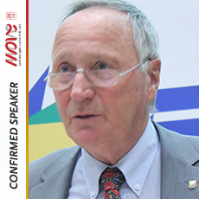

**Prof. Dr. Herbert Hartmann** is Professor (retired) for sport science University Darmstadt (Germany).

Main subjects of teaching and research: sport and education; historical and topical perspectives of sport development; quality management in organized sport; sport for senior citizens; health enhancing sport.

Involvement in organized sport: General Gymnastics-Board-member in the German Gymnastic Federation (responsible for senior-sport). Member of the expert-group of BAGSO (Federal Association for Senior Organisations). Vice-president of the International Sport and Culture Association (ISCA). Active in different European Networks (Education; Volunteering; Active Aging).

**Friday 18.10.2013: Workshop 5 - Active Aging**

**Prof. Dr. Walter Brehm, German Gymnastic-Federation**

**Target groups and fitting exercise programs for older people**

“Exercise” (like fitness training or aerobic exercise) was shown to be more effective for improving fitness and health than “sport” (like soccer or golf) and “everyday life activities” (such as gardening, shopping or walking to bus station). As for the type of physical activity and exercise there is agreement that recommendations should include *quantitative advice* (“accumulate two to three hours per week or more of PA of at least moderate intensity”) as well as q*ualitative advice (“*include in the above amount of physical activity exercise to promote endurance, strength, flexibility and relaxation systematically”). That means, exercise programs should be planed and conducted under consideration of this knowledge and these recommendations. Also very important are the preconditions of the exercise participants. Exercise programs only are fitting to target groups when such physiological as well as psycho social and behavioral preconditions are included. This is especially important in older age groups when the differences in preconditions are increasing. The results of the “active age” work-group concerning differentiation of target groups and recommendations for planning exercise programs are outlined as well as examples from different European countries.

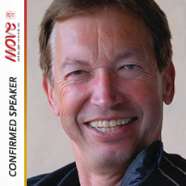

**Friday 18.10.2013: Workshop 5 - Active Aging**

**Ingrid Peetersen; OKRA Sport, Belgium**

**Good example from Belgium - Designing strategy and actionplans for older people in organised sport**

It’s important to make a strategic planning if you want to reach specific goals.

In Flanders (Belgium) recognised and subsidised sportfederations are required to make a strategic plan based on 5 main tasks:

* Organizing sportactivities
* Organizing education
* Guiding Sportclubs
* Informing clubs and members
* Promoting Sportactivities

We use the following procedure to determine our strategic and operational objectives on long terms (4 year) and in Year Action Plans.

* Data collection: facts – inventarisation and evaluation of previous activities – results of analyses
* Conclusions based on this data collection
* Formulate strategic and operational objectives for 4 years and translate them in Year Action Plans

The projects ‘Every step counts’ and ‘Every pedal counts’ are concrete translations of this way of working.

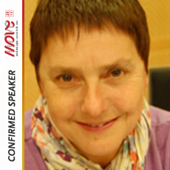In this workshop we will show you how strategic planning

**Friday 18.10.2013: Workshop 5 - Active Aging**

**Leeni Asola Myllynen; SVOLI, Finland,**

**Pathways to solve instructors’ needs and recruitment in active age project in Finnish Gymnastics Federation**

ACTIVE AGE PROJECT 2013-2016 IKILIIKE IN GYMNASTICS FEDERATION

The federation estimates that at least 1/3 of gymnastics clubs arrange exercise activities for 60+ aim group at this moment. Aims of the project, which is linked to the international Active Age project hosted by Deutscher Turner-bund, are multifaceted: More physically active seniors in gymnastic clubs, more activities suitable for seniors, more instructors, better capacity and knowledge for instructors, more knowledge and capability in the federation and in the clubs, new ways of working, more co-operation at all levels of operations.

BACKGROUND OF THE INSTRUCTORS AND NEEDS

In the survey, which mapped out the situation in the gymnastics clubs in May 2013, was found that a lot of instructors have a professional background: Physiotherapists, physical education teachers, sports instructors. The instructor group is very heterogeneous in their knowledge and experience.  
The question about what do the clubs need/want from the federation brought a clear top three: education for the instructors, material for instructors like training session models/ exercise ideas/ teaching models, music and good practices how to carry out successful group training for elderly people.

RECRUITMENT OF INSTRUCTORS

In the survey 2011 for the gymnastics clubs the most efficient way to recruit new instructors/ coaches was to recruit people who either were already or had been in the club. Instructors were also found through the grapevine and their own networks. Advertisements in different places did not work at all.

WHAT IS THE SUITABLE KNOWLEDGE AND EXPERTISE

Active Age instructors need to help their participants to understand and to be able to put into practice the aims of “Weekly Physical Activity Pie” (by UKK Institute).This is the recommendation for health-enhancing physical activity for adults aged 18-64/over 65 years. Our new education modules will be clearly based on the sectors of this pie. Also the operative solutions of educations need to be renewed: learning inside the club with tutors, supportive material in internet, participant material etc. The education will probably follow the basic idea of *Gymnastics School* -consept, which our federation developed for children for 5-6 years ago.

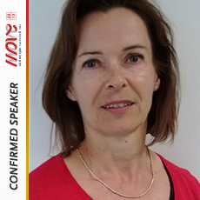**Leeni Asola-Myllynen** works as Health Activities Manager in Finnish Gymnastics Federation, Finland. She has a long experience in gymnastics for all activities, events, education and projects for adults and seniors. She has also been involved in several international sport for all workshops and seminars. She has a background in physical therapy and Master of Health Sciences from the University of Kuopio.

**Friday 18.10.2013: Workshop 5 - Active Aging**

**Anna Elisabeth Kooreman, UISP, Italy**

**Good example from Italy - Excercice program for seniors in UISP**

**INTEGRATED PROJECT**

Our goal is to devise and implement – in concert with health and social authorities – new policies for promoting healthy lifestyles for elderly, based on all-accessible movement programmes.

The proposals we present:

**Low-impact Exercise Programme** (LEP), since 1977 proposed by UISP, providing all-accessible “light” movement for health improvement and maintenance.

**Adapted Physical Activity (APA)** which is specifically “tailored” to cope with the diminished function resulting from chronic conditions such as joint disease (spinal column, hip and knee), recovery from stroke, Parkinson’s, heart diseases and bronchial diseases.

**Home-based Exercise Programme (HEP)** whose objective is the recovery of psycho-physical efficiency, namely the recovery (partial though it may be) of self-sufficiency in everyday life activities and a significant improvement of social relations and activities for seniors who, though not suffering from any chronic conditions, won’t “venture out” anymore due to prolonged inactivity, bedridden periods, solitude or depression.

**Community-based Exercise Programme (CEP)** helps the elderly community-residing people

regain their remaining abilities and develop the relevant awareness – also as for many serious diseases such as Alzheimer’s and Parkinson’s – so that they will maintain their own operation ability as long as possible and, mostly, cope with it in everyday life.

**Walking Groups, Anti-obesity Groups, Cardio groups, Diabetes groups, WaterMotion and Aquarobics.**

**Involvement of the local authorities, provincial, regional and national Health Services.**

**Involvement of private foundations**.

**Promotion and publicity of the activities.**

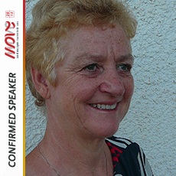

**Friday 18.10.2013: Workshop 6 - Grassroots sports organizations and young entrepreneurs**

The aim of this workshop is to explore why it is important for young people to be involved in sports organisations and how they can take a role in leading. It will look at, how to encourage young people to be involved and what kind of activities are needed to engage young people to take up leadership. It will bring in experience from youth activities and project, projects, campaigns and leadership programmes and share live example of where this is happening in local communities.

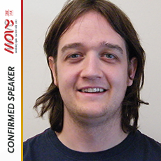**Jown Downes**

In his current role as Head of Network Development at StreetGames, he brings with him relevant experience of the voluntary youth sector and sport. StreetGames is a UK wide charity that focuses in young people and the development of sport. He has been fortunate to work there since 2007, where he helped create the programme from inception, and grow it to a UK wide programme.

Previous to thisheI worked for Manchester Youth Volunteering Programme (MYVP) running a successful sports volunteering programme from when he started in 2002. his entire career has been in youth volunteering and sport.

He has experience of working at the local voluntary youth sector and at a national representative level. he also brings with him experience of working in a youth led way and in partnership with a range of other national and regional youth organisations.

In his spare time he is also a keen sportsman and has acted on the committees of a number of sports clubs. His main passion is for the outdoors, in which he has acted as a volunteer for the Duke of Edinburgh’s awards by supporting young people in their award.

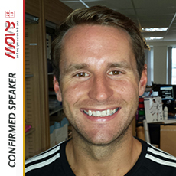**James Gregory** has been managing community sports projects like STREETGAMES ever since he left school in 2000. Sport 4 NRG is James's Doorstep Sports club and it provides FREE sports sessions to keep young people active, occupied and out of trouble.

James also delivers non formal education through sport to increase the chances of young people entering further education or employment.

James is also responsible for developing local sports and leisure facilities as well as play areas.

James is also a DSA for StreetGames UK; where he travels the country advising other community sports projects on how to strengthen their provision.

He is also a member of ISCA's Pool of International Trainers specialising in sport for personal and community development.

When he is not working he can be found on either a football pitch or a golf course!

**Friday 18.10.2013: Workshop 7 – Good Governance in Grassroots Sport**

**Darren Bailey, The FA; EU Expert Group of Good Governance in Sport, UK**

**Future of the Good governance in sport: next steps!**

With the pressure to maintain volunteer involvement and grow participation numbers, the issue of Good Governance has not always been a high priority. However, with stakeholder expectations rising, increasing demands being imposed by governments in relation to funding conditions and the ever present risk of legal challenge, the adoption of flexible and proportionate Good Governance policies and principles is now a vital tool at all levels in minimising risk, delivering effective sports policy and avoiding disputes that divert valuable human and financial resources away from development activities.

Good Governance embraces a range of measures, including clarity of purpose, the establishment and implementation of a code of ethics, stakeholder engagement, the adoption of minimum democratic standards and the introduction of sports specific disciplinary procedures. Within all sports bodies, including those that operate at the grassroots level, there should now be in place appropriate management oversight arrangements based on clear policies in areas such as dealing with conflicts of interest, financial reporting and risk management.

In general, wherever possible, grassroots sports bodies should aim to develop an overall governance structure that is fit for purpose and embraces the appropriate checks and balances to promote transparency, accountability, democracy and inclusivity. To do so it is important that grassroots sports bodies embrace a culture of good governance beyond mere rules, regulations and policies and in this regard, leaders and managers in grassroots sports bodies have a vital role to play.

Good Governance also has an important function in promoting inclusivity and youth engagement. Grassroots sports must attract people from the widest possible talent pool into all positions and by adopting robust inclusivity strategies as part of an overall framework of Good Governance, sport bodies can reflect the diverse nature of society and their participants as well as boosting  the long term viability of the sport.

Darren Bailey joined The FA as Director of Football Governance and Regulation in March 2009. Building on a coaching and football background Darren has continued to pursue twin interests in sport and law. In private practice he became Head of Governance and Commercial at a leading specialist Sports Law practice working for a range of clients including the International Tennis Federation, European Rugby Cup and Six Nations before going on to become the first in-house Legal Counsel at the International Rugby Board (IRB) in Dublin. Whilst at the IRB Darren developed the world wide regulations of the sport and oversaw all legal work associated with the 2003 and 2007 Rugby World Cups. He also moved into a wider role in legislative affairs which included building strong relationships with the European and international sporting family. Darren now has responsibility for a wide range of matters within English Football Governance and Regulation including discipline, anti-doping, integrity, equality and child protection, financial regulation, and on-field and off-field regulatory matters. He was a member of the Sports Betting Integrity Panel that produced the Parry report in 2009 and is a member of the Sports Betting Group established following the report. He is also currently acting as co-chair of the European Union Expert Group on Good Governance which is considering issues relating to match fixing, good governance for sports bodies, player agents and the transfer system. He has edited the international sports law newsletter Sports Law Administration and Practice for over 12 years.

**Friday 18.10.2013: Workshop 7 – Good Governance in Grassroots Sport**

**Sylvia Schenk, Transparency International Germany**

**The autonomy of grassroots sport in the light of internal and external expectations on governance**

The autonomy of sport organizations is highly valued – it is part of the freedom of association and the foundation for self-organized sport in many countries. Autonomy implies accountability, without responsible leadership sport clubs and federations will not achieve the best for their members and will fail in contributing to a positive development of the society.

Transparency has become an important issue, all over the world people are requesting information, they want to be involved and to have a say in decisions that may have an impact on them. Governments, local administrations and even companies have reacted and started a dialogue with their stakeholders. Grassroots sport organizations have to follow this example. The own members are expecting it, but as well public donors and private sponsors. The European Union sees good governance as condition for autonomy and financial support of sport, some municipalities already link the contribution for local sport clubs to achievements in leadership skills and a professional organization. On the global level sponsors are preparing guidelines for “Sport sponsorship and hospitality”, thus trying to set standards for integrity in a sponsorship. This is not focused onto high performance sport but includes grassroots sport.

Grassroots sport organizations should respond to these expectations by using their autonomy to lead the path as early as possible to good governance.

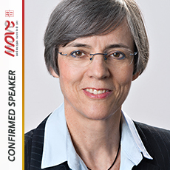**Sylvia Schenk** is a lawyer in Frankfurt on Main, Germany. She worked as a judge at the Labor Court of Offenbach (1979 – 1989) and as a City Councilor in Frankfurt (1989 – 2001).

She has been German Champion and Olympic athlete in 800m running 1972 and served as a volunteer in national and international sport organizations since 1975. From 2001 – 2004 she was president of German Cycling and from 2000 – 2005 member of the Management Committee of the International Cycling Union UCI. From 2007 – 2010 she was Chair of Transparency Germany and since 2006 she is Senior Advisor for Sport of Transparency International. She is a board member of the German Olympic Academy and an arbitrator at the Court of Arbitration for Sports (CAS) in Lausanne.

**Friday 18.10.2013: Workshop 7 – Good Governance in Grassroots Sport**

**Mikkel Larsen, Sport and Recreation Alliance, England**

**Governance – why is it so important that the sport and recreation sector gets it right?**

In 2007 the European Commission adopted the White Paper on Sport which acknowledged the autonomy of sport and that *“Governance is mainly the responsibility of sports bodies”*. There was also an admission that sporting bodies themselves are best placed to know how best practice is implemented.

Defending sport’s right to govern itself is under threat – taxpayers’ money is being invested with the aims of more medals and improving public health. With these aims come the reasonable demands of accountabilities and transparency.

As a result, sport must show it has the skills, desire and structure to get this right – if not we might see a limit to our autonomy.

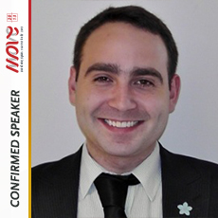Mikkel is a Sport Management graduate from Birkbeck College, University of London. Mikkel moved to the UK from his native Denmark to study his postgraduate degree having had a short stint in Manchester assisting Visit Manchester on their Manchester World Sport campaign. Before moving to the UK, Mikkel was employed by the major coalition party in the Danish Government.

Mikkel is the Governance Officer in the Sport and Recreation Alliance, in charge of governance and compliance projects, and co-author of the Better Boards, Stronger Sport which identified key features and requirements for effective sports board across Europe.