Curriculum Vitae
Prof. Dr. Herbert Hartmann

Geb. 15.11.1938

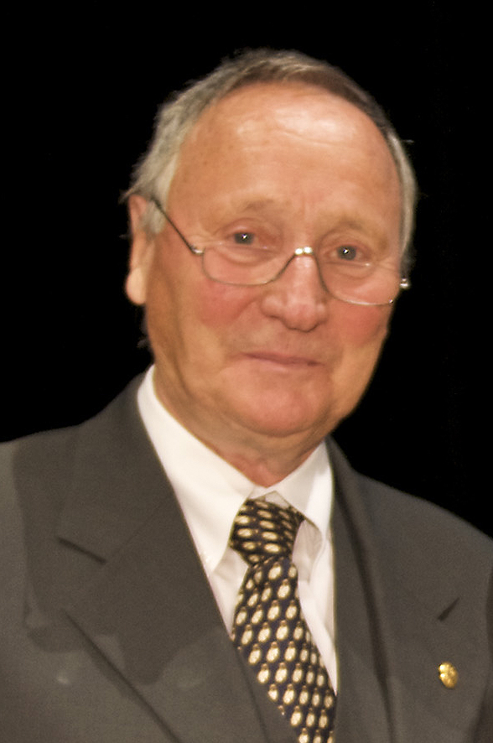
Professional work:
Professor (retired) for sport science University Darmstadt (Germany).
Main subjects of teaching and research: sport and education; historical and topical perspectives of sport development; quality management in organized sport; sport for senior citizens; health enhancing sport.

Involvement in organized sport:
- Former sport –political functions: Vice-president German Gymnastic Federation; vice-president German Sport Confederation; Chairman of the ISCA European Committee.
- Actual positions: General Gymnastics-Board-member in the German Gymnastic Federation (responsible for senior-sport).
- Member of the expert-group of BAGSO (Federal Association for Senior Organisations).
- Vice-president of the International Sport and Culture Association (ISCA).
- Active in different European Networks (Education; Volunteering;HEPA; Active Aging).

