International Sport and Culture Association
Tietgensgade 65
DK-1704 Copenhagen V
Denmark

7 September 2011

Nomination of Mogens Kirkeby as President

On behalf of Danish Gymnastics & Sports Associations (DGI) I nominate Mogens Kirkeby as President of International Sport and Culture Association (ISCA).

During his presidency ISCA has developed into a significant political factor in European sports policy. Furthermore Mogens has managed to enlarge the network of ISCA all over the world. Mogens is a leader with strong views and a clear vision. He combines organizational experience with political commitment in a unique way.

I can give Mogens my warmest recommendations.

Sincerely
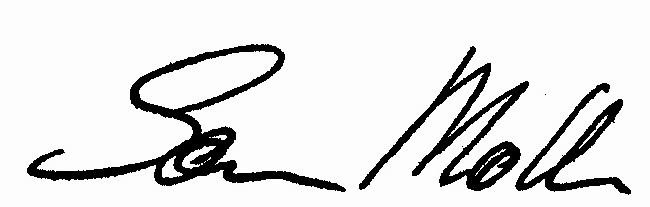

Søren Møller
President of DGI

