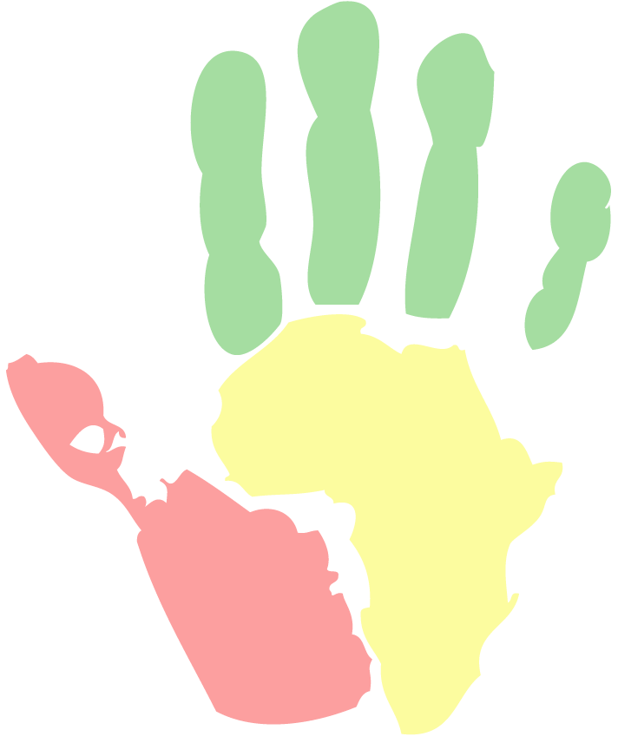***The Institute for Cultural Diplomacy******in Berlin presents:***

**Cultural Diplomacy in Africa:** **A Forum for Young Leaders**

“***The Development Game: Solving Problems and Creating Opportunities for a Stronger Continent***”

The CDA Week-long Seminar will take place in Berlin

11th - 18th June 2010

**In addition to looking in greater detail at the history and development of cultural diplomacy, the CDA Week-long Seminar will focus on current and future issues facing Africa.**

**In particular, the next CDA Weeklong Seminar will focus on the following areas:**

* **The power of sport: The 2010 FIFA World Cup and its impact on the continent**
* **Celebrating 50 years of independence: The history and development of Africa over the past five decades**
* **Africa's challenges and opportunities in meeting the Millennium Development Goals, with a particular focus on climate change, political and economic stability, and sustainable development**
* **The role of supranational economic unions in stabilizing the African continent, and the potential influence of a stronger African Union**
* **African markets as a target for foreign investment, and the impact of such investment on African development. Cameroon will be considered as a case study**
* **The involvement of international organizations and corporations in Africa and their influence on the continent's development and economy**
* **Emerging new models for African governance and development**
* **The African Diaspora and its role in the development of Africa**
* **The importance of Cultural Diplomacy and soft power in strengthening relations between African nations and within nations themselves**

Students and professionals with an active interest in Africa can apply through:

[www.culturaldiplomacy.org/cda](http://www.culturaldiplomacy.org/cda)

For more information please visit the ICD’s website:

[www.culturaldiplomacy.org](http://www.culturaldiplomacy.org/) or contact us on +49 (30) 23607680