Daniela Conti

PERSONAL INFORMATION
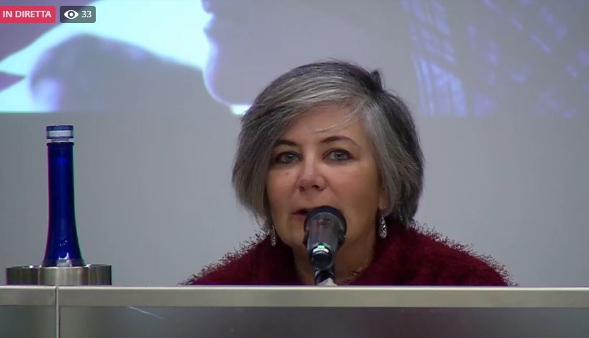 |   Via Raoul Chiodelli, 202 - 00132 Roma (Italia)

+39.348.6026025

d.conti@uisp.it

Skype danillax
 | Sex Female | Date of birth 16/07/1971 | Nationality Italian

WORK EXPERIENCE

1995–Present | Public relations, project manager, researcher, manager
1995–Present | Unione Italiana Sport Per tutti - UISP, Roma (Italia)
1995–Present | - 2021-now: Head of UISP Policies for Interculturality and Cooperation  - 2021-now: coordinator project “Sentry-Sport” (funded by Erasmus+ sport) about sport and fight against discrimination  - 2020-now: member of the direction board of Uisp Roma, with the role of responsible of the Local Training sector.  Expert in “working with marginalised people, how sport can help in a re-birth” in the project SPPF – Sport in Prison a Plan for Future (funded by Erasmus+ sport).  Mentor for empowering small sport organisation in projecting activity with sport as a tool of social inclusion for refugees, in the project IRTS platform managed by ISCA.  - 2013-now: member of the direction board of Uisp Lazio, with the role of responsible of the Regional Training sector and trainer about “UISP Social Policies: projects, actions and meaning of working with sport as a tool for social inclusion and tackling discrimination”  - 2009-now: Uisp National councillor  - 2019-2021: For Project Pinocchio (funded by AICS): trainer in the schools about sport against discrimination, expert in the realisation of the training materials, co-author of the final toolkit.  For Project EYESS – European Youth Engaging in Solidarity (funded by Erasmus+ sport): trainer about “how to create an antiracist sport event: management and realisation”; co-author of the final toolkit.  For Project Match Sport - Make Amateur Sport Tolerant and Eliminating Racism and Discrimination (funded by Erasmus+ sport): expert in the field of “social sport – changing the rules for inclusion – sport against racism and violence”, trainer in 2 international training about “How to reduce violence and discrimination in grassroots sport”  - 2017-2019: Researcher in the project PAC: Prisoners' Active Citizenship (funded by Erasmus+ sport)  - 2016-2018: for the project IRTS – Integration of Refugees Through Sport (funded by Erasmus+ sport): expert in the field of how include refugees and asylum seekers in the sport club; co-author of the guideline and training materials.  - 1998-now: part of the Mondiali Antirazzisti's organising staff with different role: responsible of communication sector (promotion, press office, social media), responsible of cultural programme, coordinator of InfoPoint and Reception.  - 2015-2021: responsible of UISP relationship with international sport association, inside the department International Policies, Multiculturality and International Cooperation.  - 2013-2019: member of the Council of Uisp Roma, with the role of President of the Council.  - 2012-2015: chief of the UISP International Projects department  national coordinator of the Project “Il calciastorie” in cooperation with Lega Serie A, about football against discrimination  - 2011-212: coordinator project “Mimosa” (funded by Unity Sport – DG EAC) about sport and social inclusion.  - 2010-2011: coordinator project Olympia (funded by Unity Sport – DG EAC) about gender equal opportunity and sport; co-author of the “European Chart of Women’s right in Sport”  - 1999-2015: co-operation with FARE network (Football Against Racism in Europe) with the role of co-ordination and lobbying, reporting and organization of international meetings, international board member.  - 2007-2009: cooperation with the International Relationship Area and the Social Policy area of UISP, with the role of counselling  - 1997 - 2009: co-operation with Progetto Ultrà-UISP Emilia Romagna for co-ordination, translation, organising support, public relation  - 1999-2003: co-operation for the project “Via del Parco” of UISP Nazionale, as counselling for projecting and national co-ordination  - 1995-2001: elaboration and projecting of 50 European projects (among all Leonardo, PIC, Life, Programme against social exclusion, Prince) 12 founded by European Commission  - 1997-1999: responsible for the social research of two European projects: “Vocational possibilities in the area of sport for disadvantaged young people” for Progetto Phoenix, founded by Youthstart and “Vocational possibilities in the sport and environment sector” for Progetto Nuovi Sentieri, founded by Integra  - 1998: teaching for the Transnational Seminar for Youth for Europe (Ente di Formazione Atelier Siena), on the topic “Sport as a tool of rescuing and occupation” (07.04.1998)  - 1995: teaching for the Seminar “Training and Specialisation for teachers of tennis”, organised by Lega Tennis UISP (29-30.09/01.10.’95)
2020-2021 | Evaluator
2020-2021 | Evaluator for EACEA (European Commission) of Small Cooperative Partnership projects presented for the Eramsus+ Sport Programme 2020 and 2021

1993–2000 | Sociologist
1993–2000 | University of "La Sapienza", Rome (Italy)
1993–2000 | - 1999-2000: participation in the research "Survey about the values of the young managers of the Third Sector" (Prof.ssa Ochhionero, Prof. Porro), with the role of editing of the questionnaire and data elaboration  - 1993-2000: participation in the organisation of several seminars and conferences at the University, with the role of organisational secretary  - 1996-1998: collaboration with the Department of Sociology and Sociology of the Administration, with the role of professor's assistant, managing of the data bank and tutoring of student preparing the thesis.  - 1996: participation at the research "Young people between sports and sedentary in metropolitan realities. Survey on the sports practice of young people from compulsory school in Rome", promoted by the department of Statistic, probability and Applied Statistics, with the role of editing of the questionnaire, briefing and coordination of the interviewers  - 1996: participation at the research "Sport, Identity and Communication", realised by department of Sociology and commissioned from RAI - verification and quality of the programs transmitted, with the role of elaboration of the questionnaire, graphic elaboration of the results and elaboration of the report "World Cup in internet"

1991–1995
1991–1995 | - waiters and kitchen maid in different restaurants in Rome  - babysitter and private lessons for kids 6-11 years old

EDUCATION AND TRAINING

01/10/1990–13/07/1995 | Degree in Sociology
01/10/1990–13/07/1995 | University "La Sapienza", Rome (Italia)
01/10/1990–13/07/1995 | Thesis title: “A paradigm in evolution: the ‘multiple identities’ of tennis. Survey about the tennis clubs in Rome”.  Vote 110/110

15/09/1985–12/07/1990 | Diploma Scientific Lyceum
15/09/1985–12/07/1990 | Liceo Scientifico F. Enriques, Rome (Italia)

1995–1996 | • Post-lauream course: “Cultural Anthropology of the complex societies”
1995–1996 | University “La Sapienza”, Rome (Italia)

PERSONAL SKILLS

Mother tongue(s) | Italian
Other language(s) | UNDERSTANDING |  | SPEAKING |  | WRITING
Other language(s) | Listening | Reading | Spoken interaction | Spoken production
English | C1 | C2 | C1 | C1 | C2
French | C1 | C2 | B2 | B2 | B1
Spanish | B2 | C2 | B1 | B1 | B1
Portuguese | B1 | C1 | A1 | A1 | A1
Levels: A1 and A2: Basic user - B1 and B2: Independent user - C1 and C2: Proficient user
Common European Framework of Reference for Languages

Communication skills | Excellent skills of public relations and building network, due to the long experience of work in the social sectors

Organisational / managerial skills | - Excellent organisational skills in leading small staff  - Good capacity of problem solving  - Excellent capacity of working in group, with the ability of adaptation at the situation, different people

Digital skills | SELF-ASSESSMENT
Digital skills | Information processing | Communication | Content creation | Safety | Problem solving
 | Proficient user | Proficient user | Proficient user | Basic user | Independent user
 | Digital skills - Self-assessment grid
 | Good command of Office (Word, Excel, Publisher, Power Point) and Photoshop.

ADDITIONAL INFORMATION

Publications | - 2021: co-author Toolkit “Riconoscere le discriminazioni, educare all’uguaglianza” – Project Pinocchio  - 2018: co-author “Implementation Guide for Integration of Refugees through Sport” – Project IRTS  - 2018: co-author Methodological Guide “SportAntenne” – Project SportAntenne  - 2012: co-author Methodological Guide "Social Inclusion through sport: a possible model " - Project Mimosa  - 2015: co-author methodological Guide “Il Calciastorie. Storie di Integrazione dal profondo del calcio” – Project Il Calciastorie  - 2011: co-author "European Chart of Womens’ Right in Sport" – project Olympia  - 2004: “Calcio contro il Razzismo” (co-autore Gianluca Verde), in “Calciopolitiche”, Quaderni di Sociologia Vol. XLVIII, 2004, 34, Rosemberg & Sellier, Torino  - 1996-2002: Diverse pubblicazione di articoli sui giornali della UISP (Il Discobolo, Futuri e Area UISP) e sul sito UISP.  - “The sports system and sports organizations in Italy” (in collaborazione con Nicola Porro e Giulio Bizzaglia), in “Sport Clubs in Various European Countries” a cura di Klaus Heinemann, 1999, Schattauer, Colonia  - “A paradigm in evolution: ‘multiple identities’ of tennis. A research concerning the clubs of Rome and its surroundings”, in “Sport: Social Problems, Social Movements” a cura di P. De Nardis, A. Mussino, N. Porro, 1997, SEAM, Roma  - “Un paradigma in evoluzione”, in “Sport & Loisir”, n°2-3, dicembre 1996, SEAM, Roma

Memberships | 2011-today: Member of Sport Clubs Liberi Nantes, first club in Italy composed by refugees and asylum seekers.  President of the Association from 2012 to 2015.

